Edit Profile in Supplier Portal

Get Started
- Access your Supplier Portal: https://ewal.fa.us8.oraclecloud.com/
- Click the Home icon  in the upper right corner.
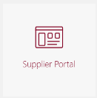
- Click Supplier Portal tile.

Open Profile
- Click Manage Profile (found under Company Profile). 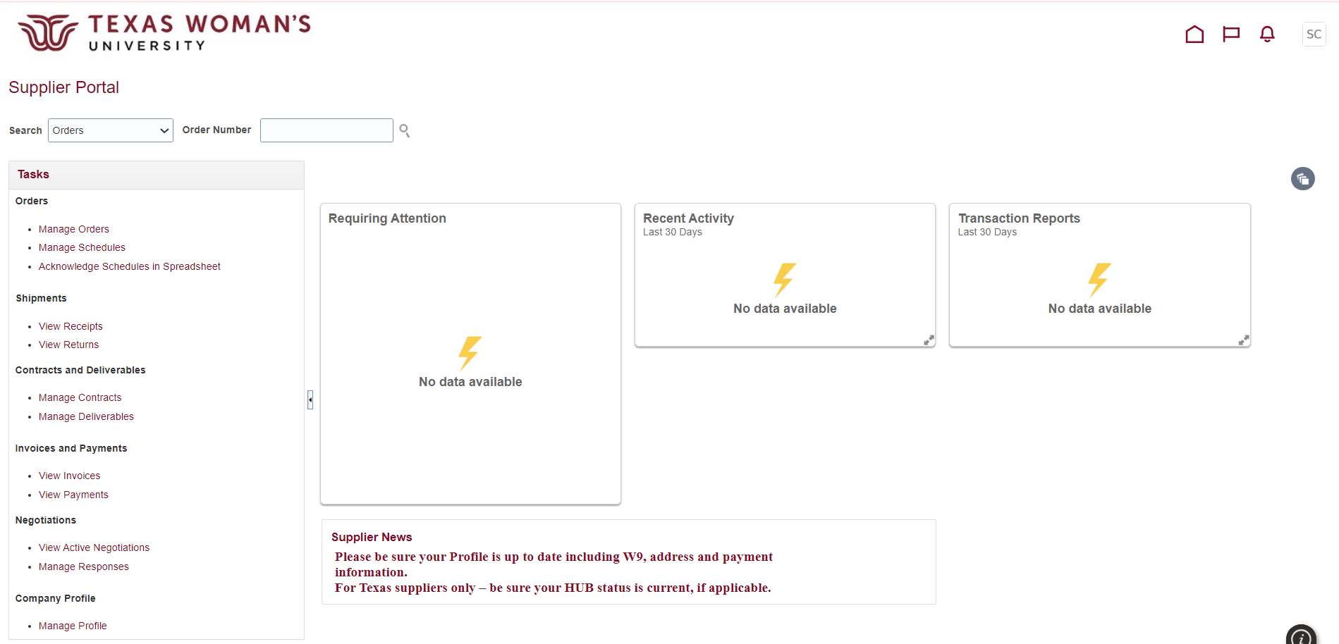

- Click Edit. 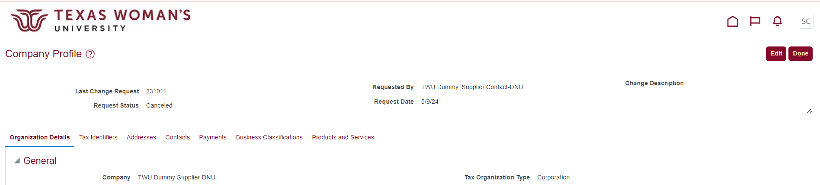

- If you see this warning, click Yes to continue with the change request. 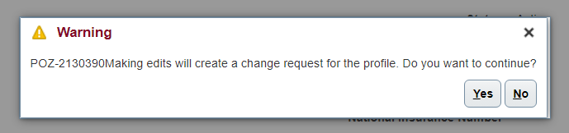

Edit Profile
- Describe the changes you’re making in the Change Description field (such as “Adding an updated W9”, “Adding our Certificate of Insurance”, “Adding a new contact”, etc.)
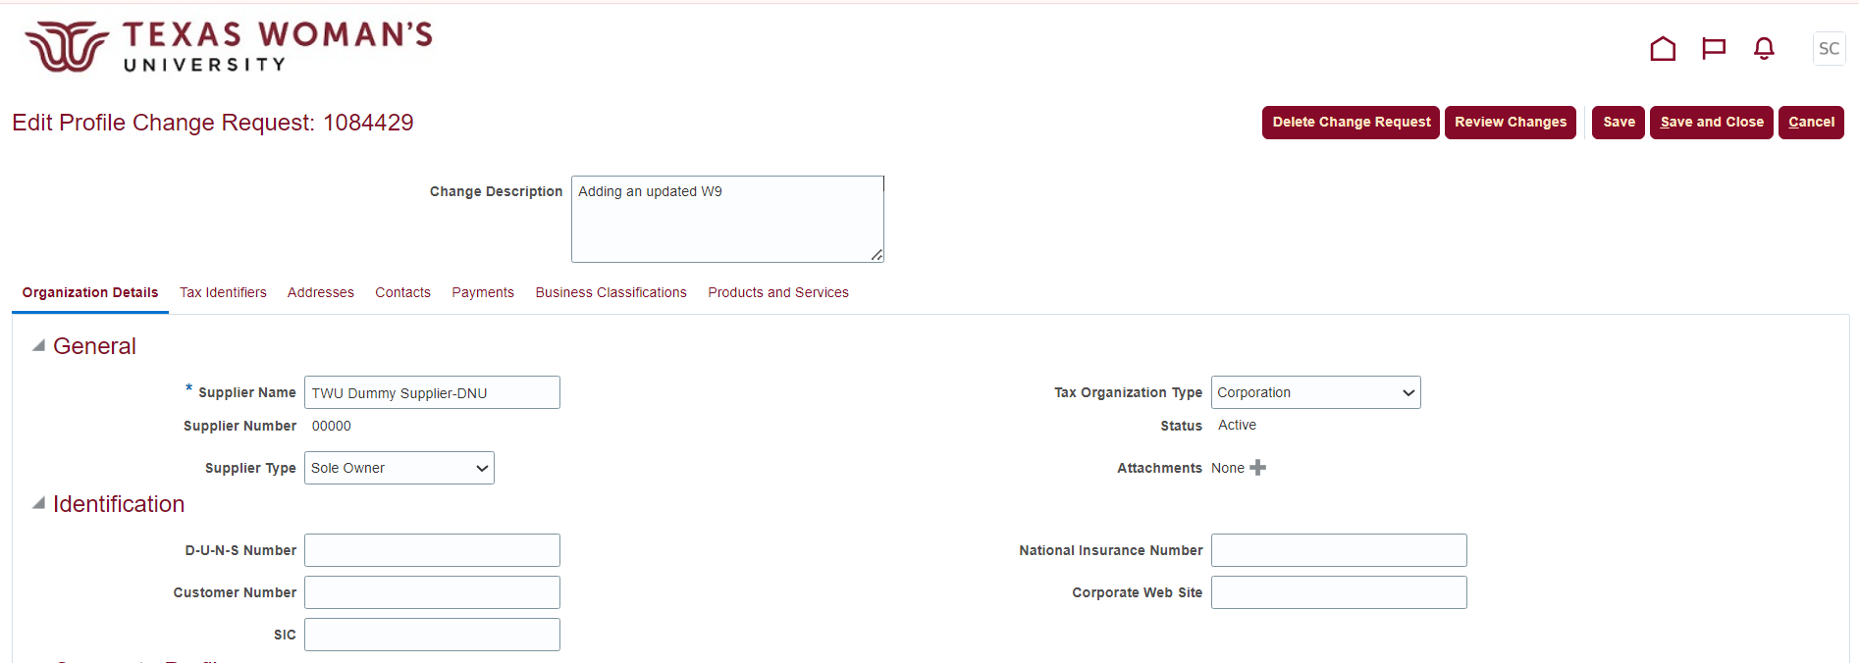

There are seven sections you can edit within your profile. Ctrl + Click to jump straight to that section.
- Organization Details – Name, Tax Org Type, Attachments (W9, COI, etc)
- Tax Identifiers – Tax Reporting Name (if different from DBA)
- Addresses – Company addresses
- Contacts – Company contacts, user accounts
- Payments – Banking information
- Business Classifications – VetHUB Certification
- Products and Services – Company specialties to display to campus

Organization Details
- The most common edit suppliers need to make in this section is adding updated documents, like W9s, Certificates of Insurance, and VetHUB Certifications. Add Attachment(s) by clicking the plus icon  next to Attachments.
8

- Click Choose File to upload a file from your computer. If you have more than one file to upload, click the plus icon , and if you need to delete a file, click the X icon  .
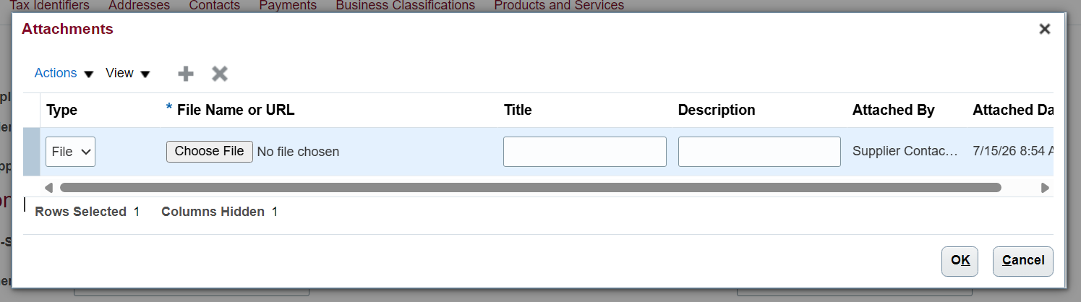

- Once you’ve uploaded your file(s), click OK.
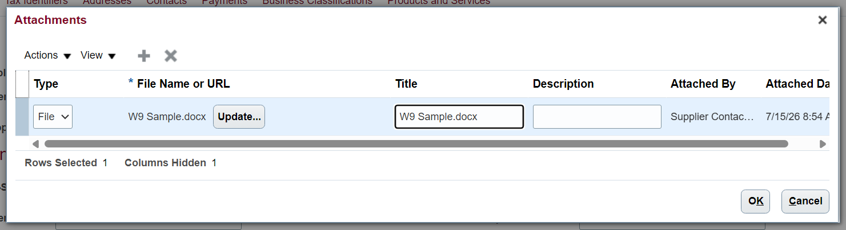

- Make sure you can see the added attachment(s), then click Save and Close.
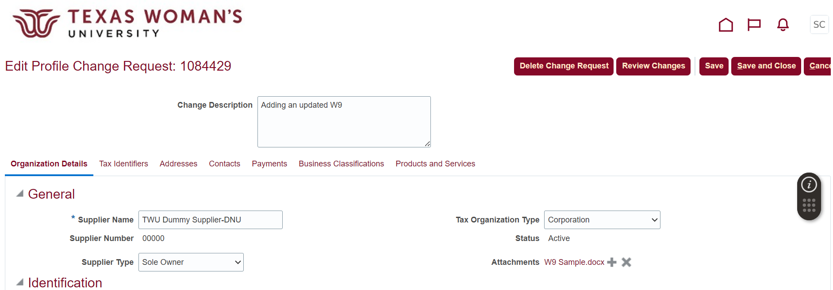

- Click OK in the Confirmation pop-up. 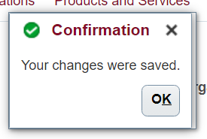
- Click Done  in the upper right corner to exit out of “editing mode”.

Tax Identifiers – Tax Reporting Name (if different from DBA)
- Select the Tax Identifiers tab, then enter your company’s Tax Reporting Name (line 1 on your W9).
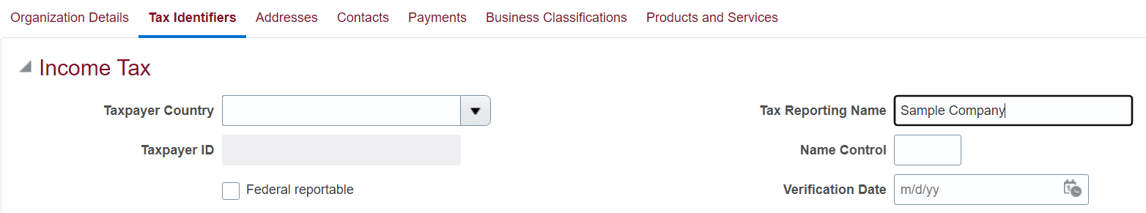

Addresses – Company addresses
- Select the Addresses tab, then click the address you want to edit -or- the plus icon to add a new address.
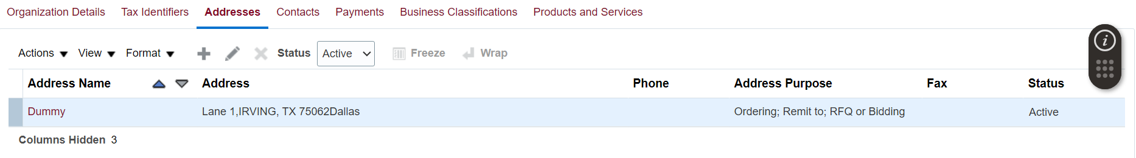

- Edit the Address name, location and/or purpose. You can also add a phone/fax number and email address to this specific location. Click OK when done.
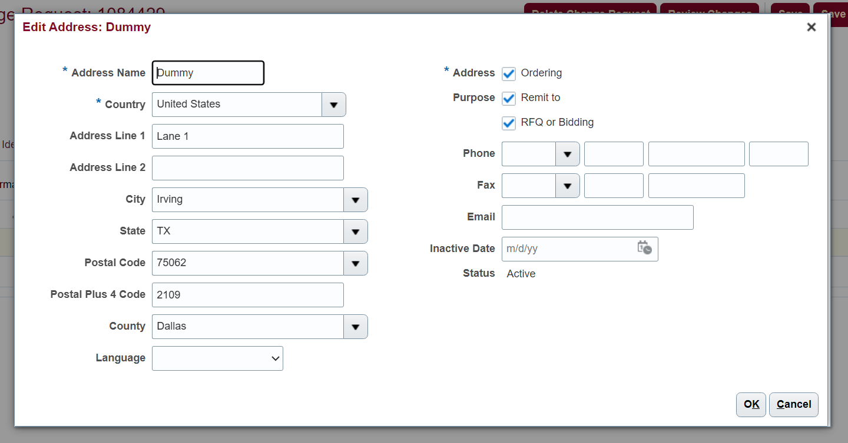

Contacts – Company contacts, user accounts
- Select the Contacts tab, then click the contact you want to edit -or- the plus icon to add a new contact.
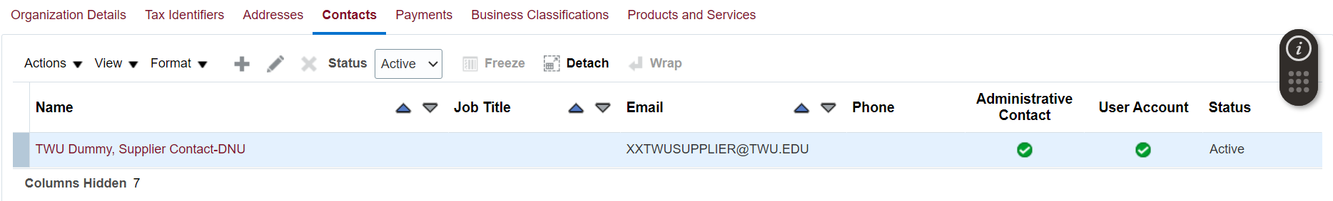

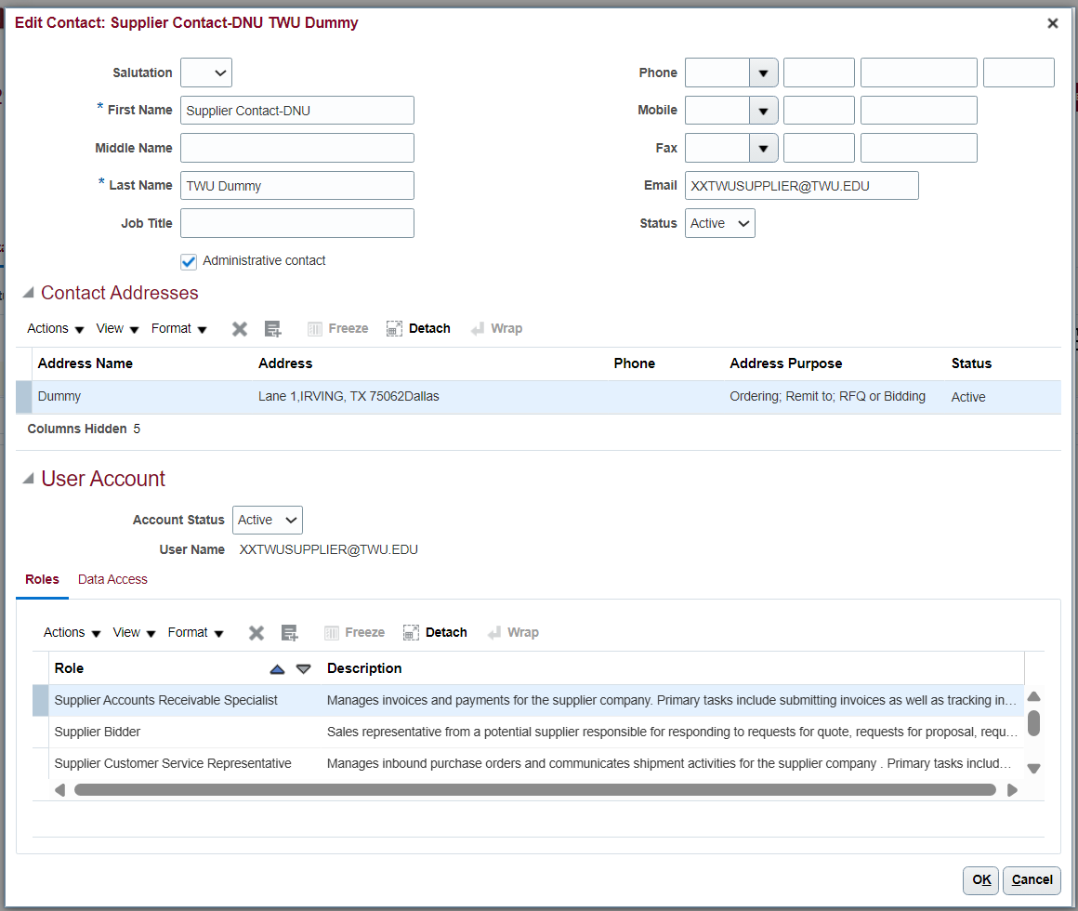
20
19
18
- Edit the name, phone/fax numbers, email, and active/inactive status of the contact.
- Associate a specific address with this contact by clicking the select + add  icon.
- Add roles to the contact to limit or expand their access.
- Click OK when done.

Payments – Banking information
- Select the Payments tab, then select Electronic (to be paid via direct deposit) -or- Check (to be paid via paper check). Once your preference is selected, click the Set Default icon  .
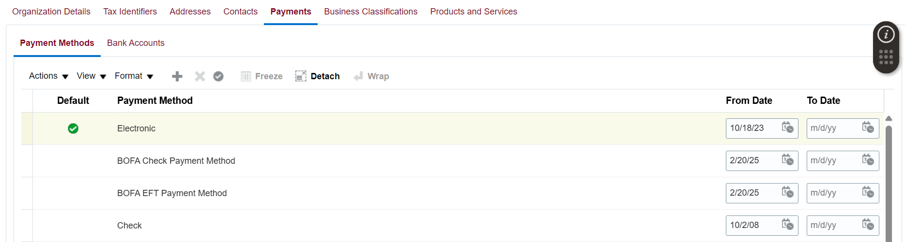

- If your default payment method is Electronic, select the Bank Accounts sub-tab, then select the listed account (to update it) -or- the plus icon (to add a new bank account).
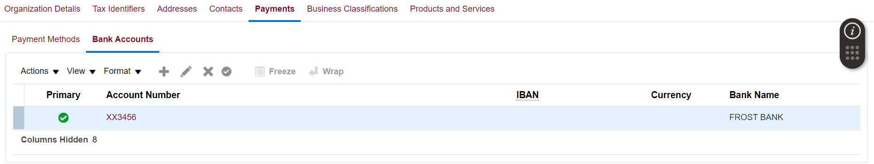

- Make sure the following fields are filled in: Country, Account Number, Bank Name, Bank Branch (routing), Currency (USD), Account Type. Then click OK.
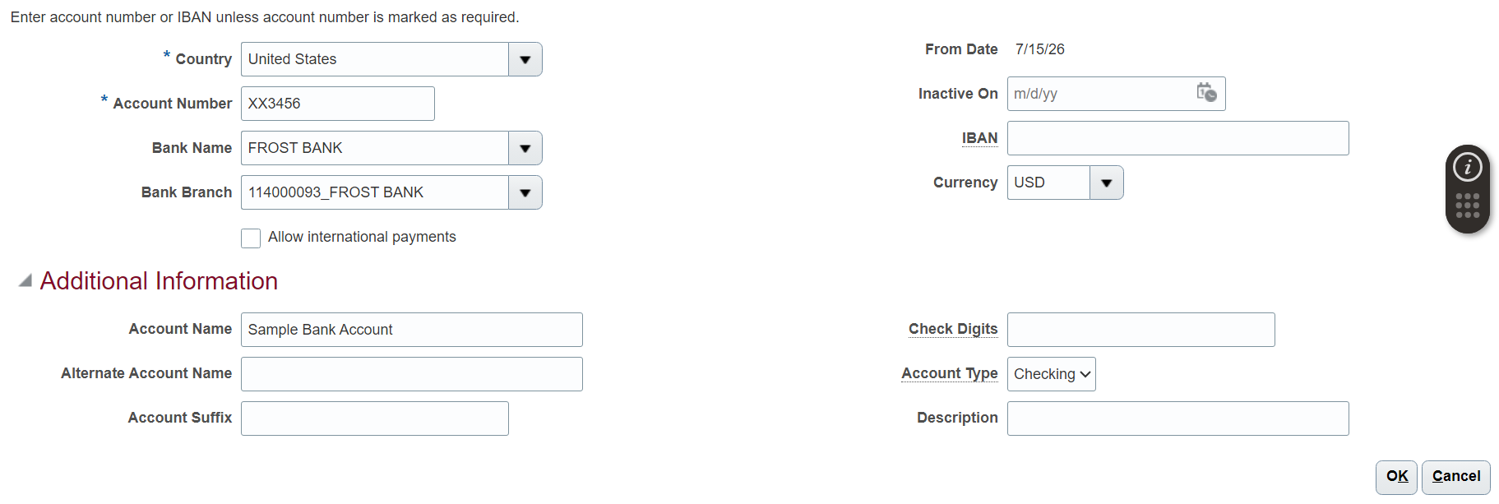

Business Classifications – VetHUB Certification
- This section is only needed for updating your company’s VetHUB status and/or uploading your VetHUB certificate. Select the Business Classifications tab, then edit your current certification as needed -or- click the plus icon to add a new VetHUB certification.
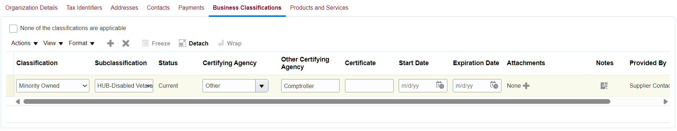

Products and Services
- Select the Products and Services tab, then click the select + add icon. Scroll through the options and select the checkboxes that best match your company’s products and services. Once done, click OK.

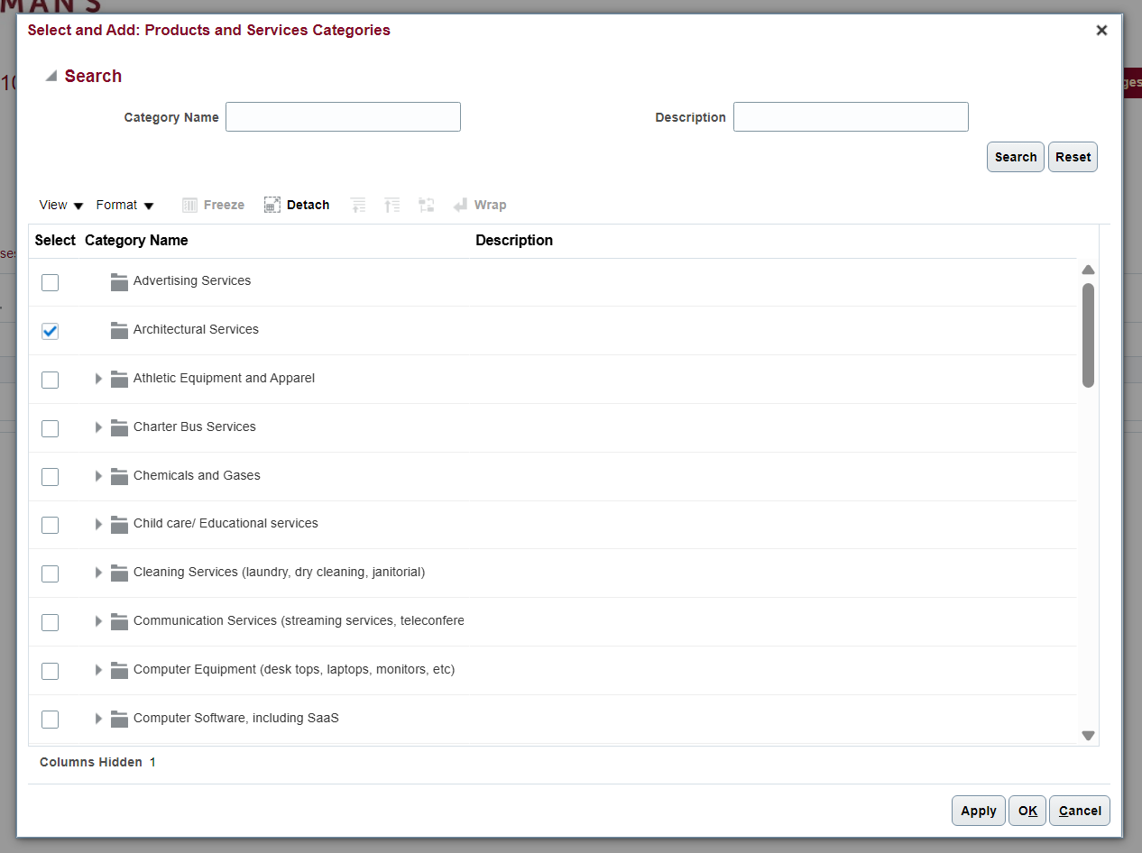

- To exit editing mode, click the Save and Close  button in the upper right corner.

