Add Files in Supplier Portal

Get Started
- Access your Supplier Portal: https://ewal.fa.us8.oraclecloud.com/
- Click the Home icon  in the upper right corner.
- Click Supplier Portal tile. 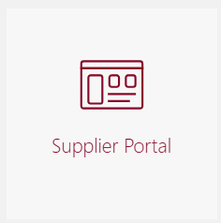

Edit Profile
- Click Manage Profile (found under Company Profile). 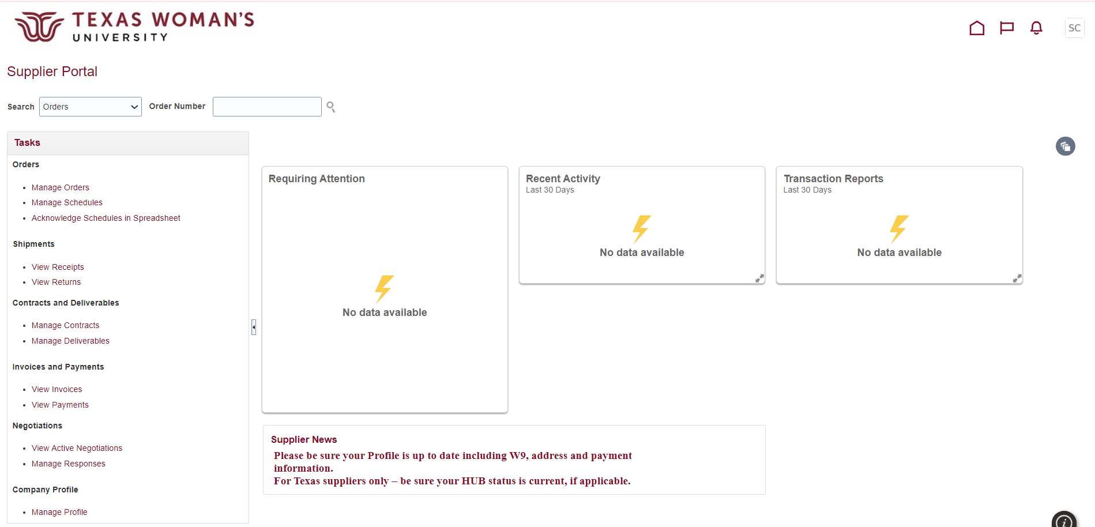

- Click Edit. 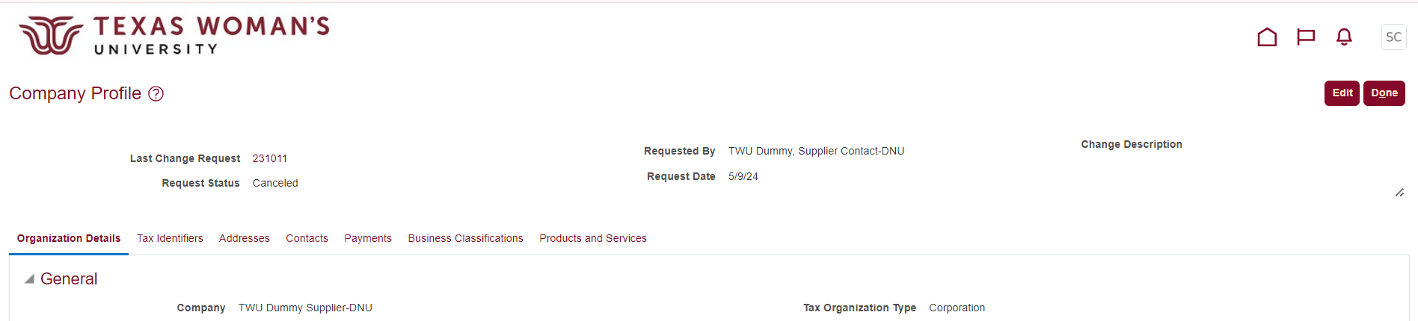

- If you see this warning, click Yes to continue with the change request. 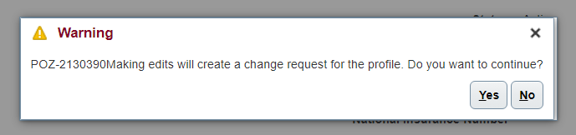

Make Edits

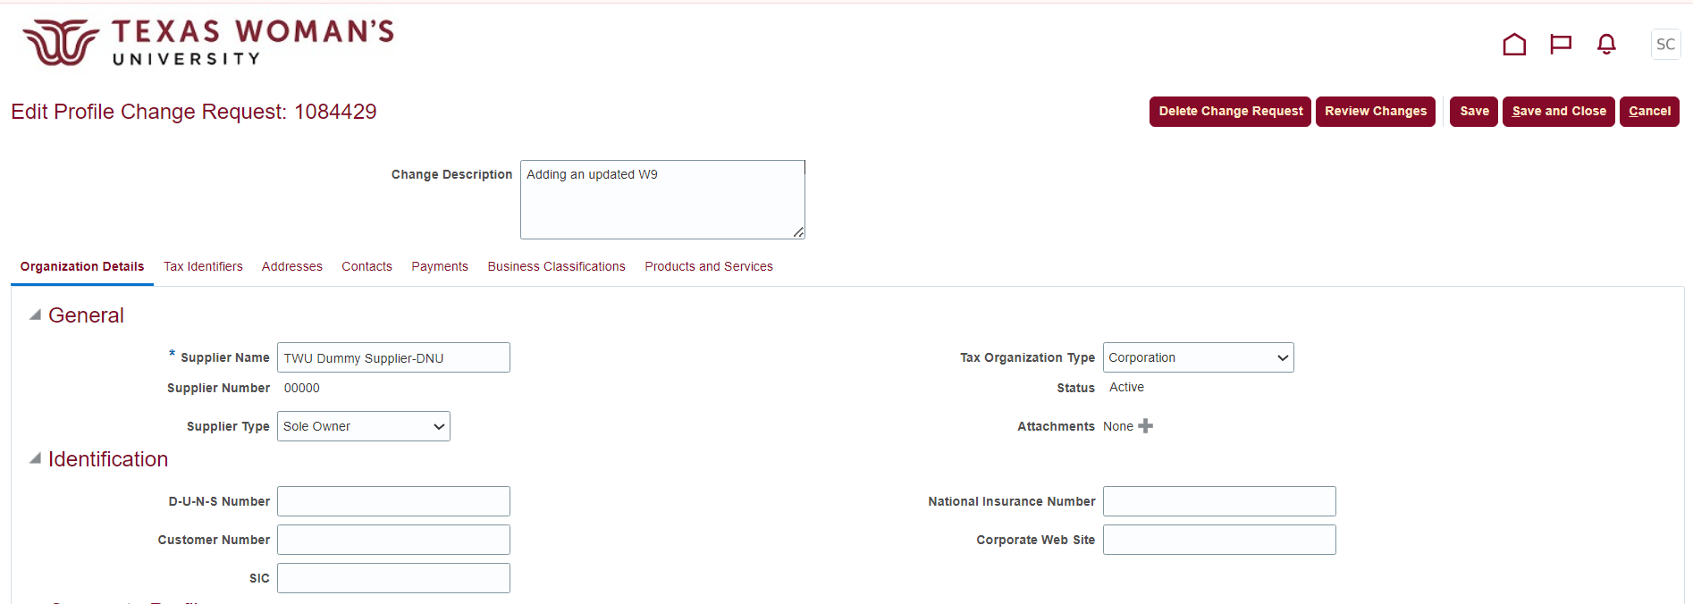
8
7
- Describe the changes you’re making in the Change Description field (such as “Adding an updated W9”, “Attaching a W9”, “Adding our Certificate of Insurance”, etc.)
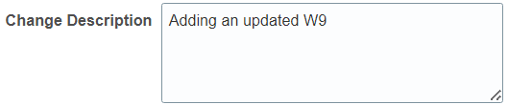
- Add Attachment(s) by clicking the plus icon  .

- Click Choose File to upload a file from your computer. If you have more than one file to upload, click the plus icon , and if you need to delete a file, click the X icon  .
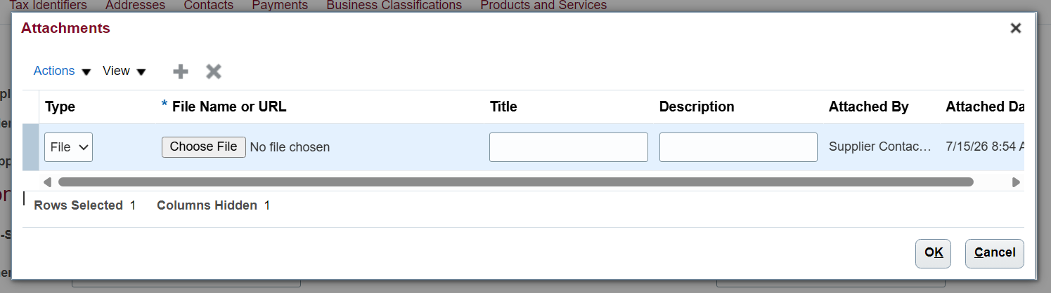

- Once you’ve uploaded your file(s), click OK.
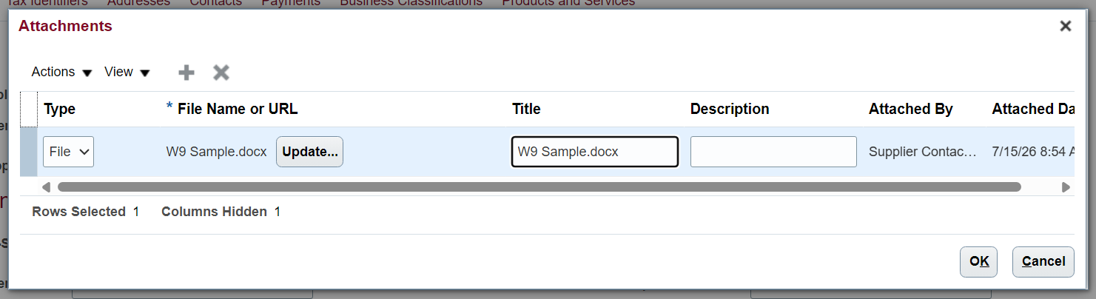

- Make sure you can see the added attachment(s), then click Save and Close.
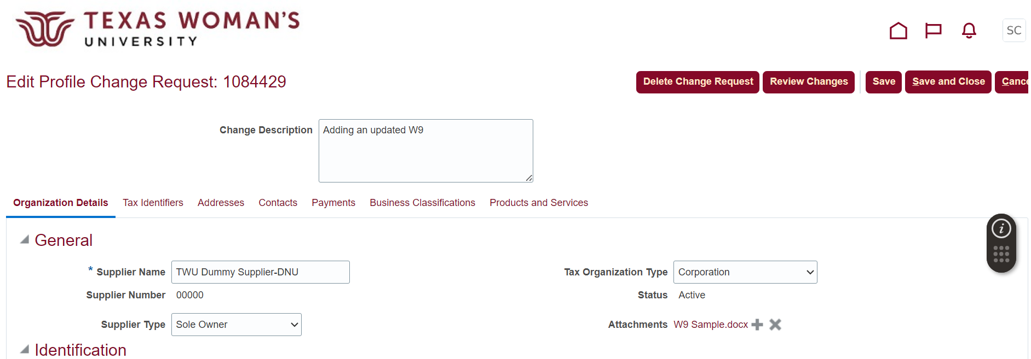

- Click OK in the Confirmation pop-up. 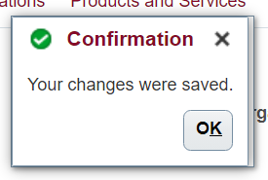
- Click Done  in the upper right corner to exit out of “editing mode”.

