

Supplier Registration Guide for Students

- Access the Supplier Portal via this link: Supplier Registration Link
- Enter Your non-TWU Email
  - Enter an email that has not been used to register another profile.
  - Retrieve the code you are sent, enter the code, then click “Continue”.

Company Details [1 / 6]

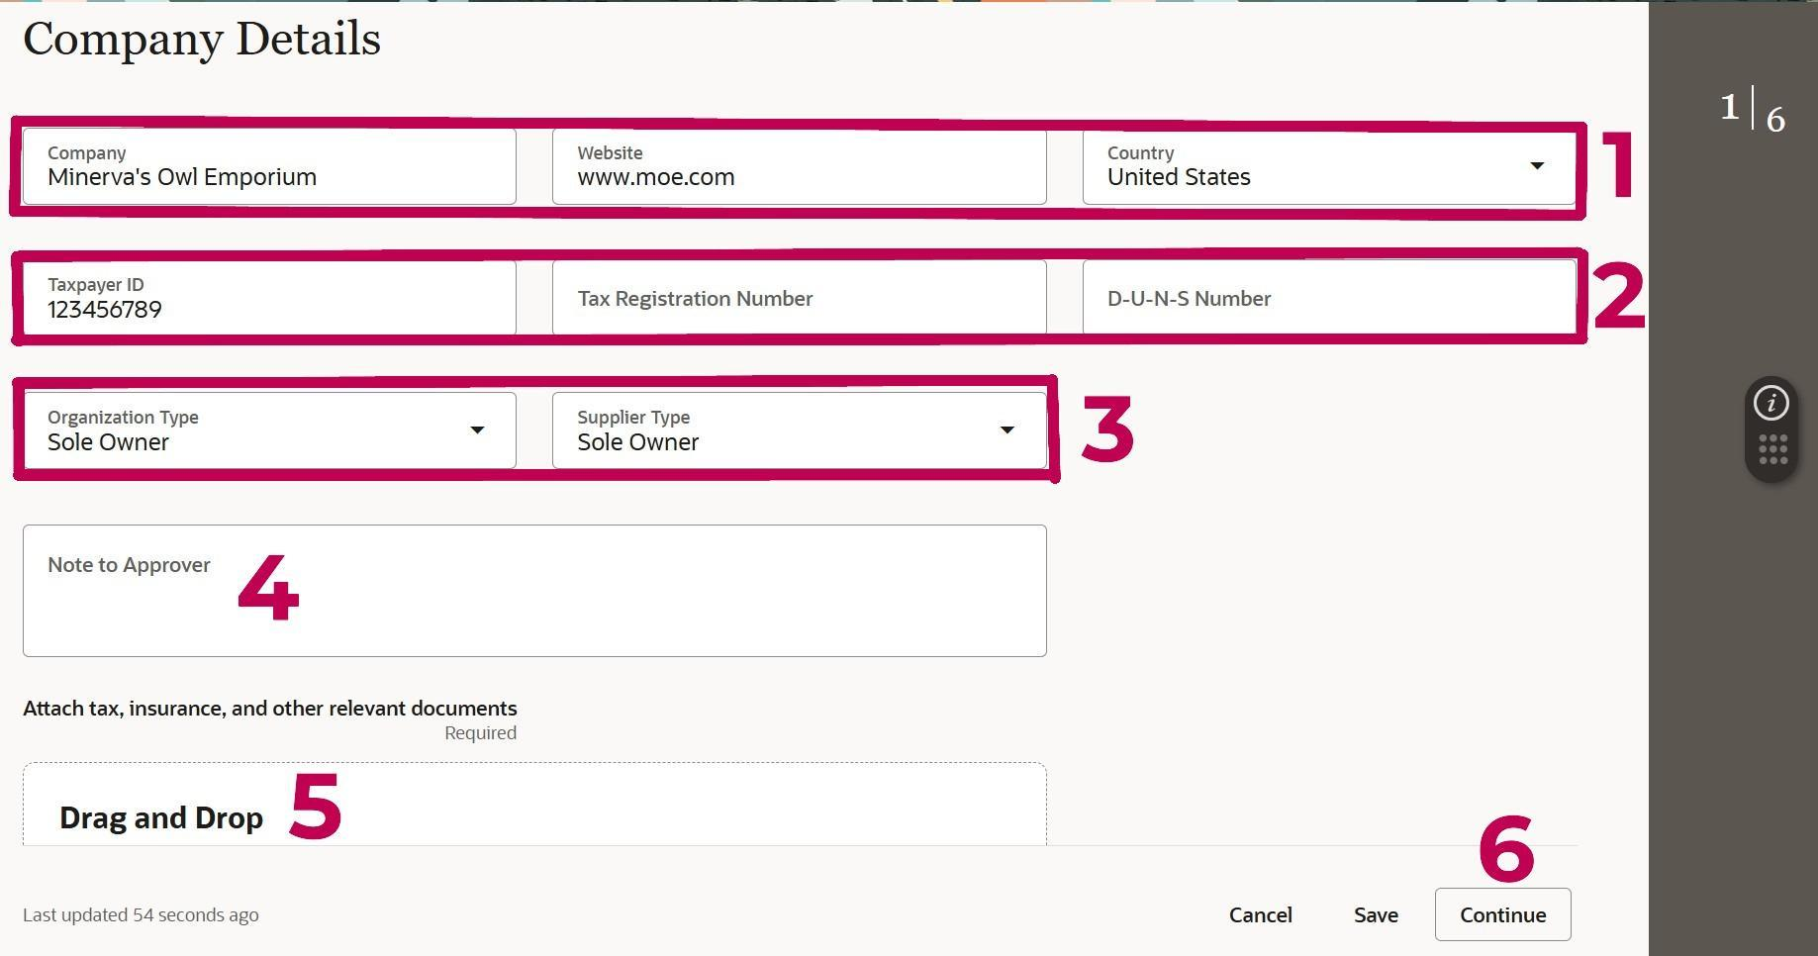

- Enter your name under “Company”.
- Enter the country name, and the Social Security number listed on your W9.
- Choose “Student” as your Organization and Supplier Type.
- Note to Approver
  - If you are receiving an award, type “This is an award” in the Note to Approver field.
  - If you are receiving a reimbursement, indicate what the reimbursement is for (ie. grant tuition, travel, food, mileage, etc) in the Note to Approver field.
- Attach a W9 (W9 MUST be signed and dated within the current year) by clicking on the “Drag and Drop” box.
- Click “Continue” in the bottom right.

Contacts [2 / 6]
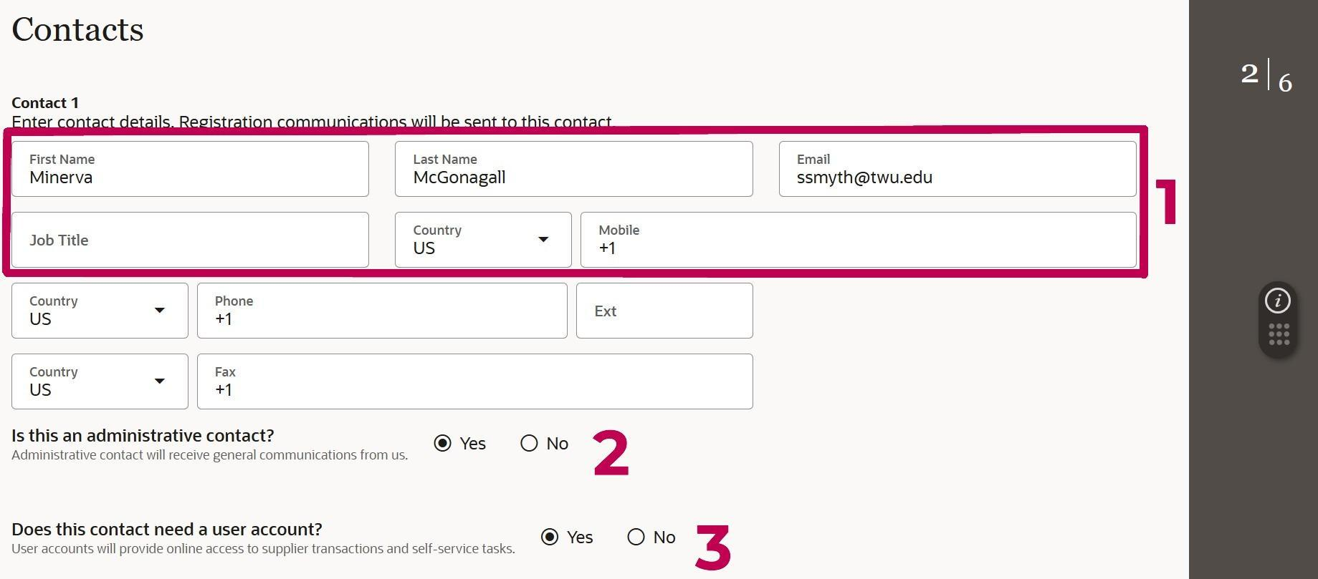

- Fill in the following fields: Name, Email, and Phone Number.
- Choose if this contact will be an administrative contact.
  - Choosing “Yes” will ensure this contact receives general communications from us.
- Choose if this contact will need a user account.
  - Choosing “Yes” will ensure this contact has online access to supplier transactions and self-service tasks.
Note: At least one contact must have a user account, but other contacts can be added just for contact information or to be linked to an address in a later step.

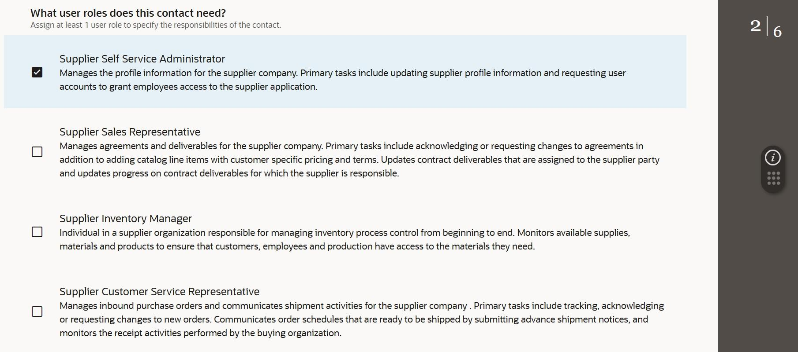
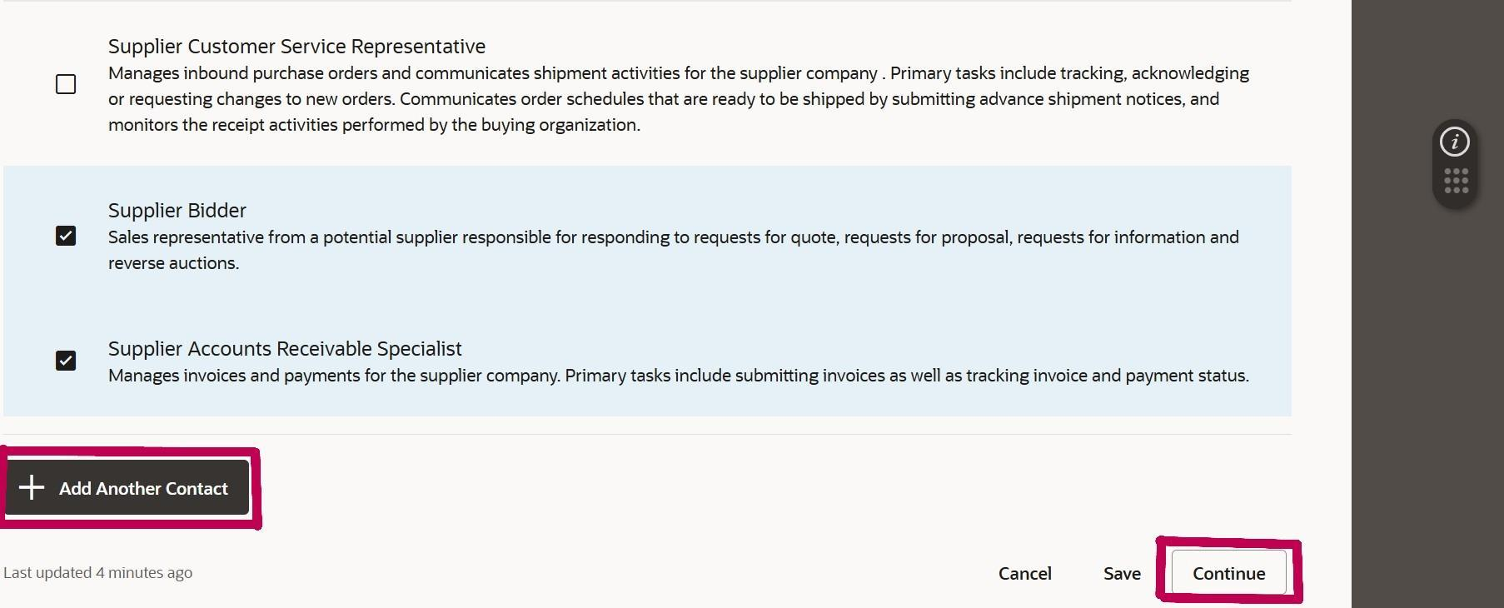

- Scroll down to assign roles to this contact.
- We suggest choosing all the following roles:
  - Supplier Self Service Administrator
  - Supplier Bidder
  - Supplier Accounts Receivable Specialist
  - Any other roles listed that feel applicable to this contact.
- At this point, you may add any additional contacts to this Supplier Account by clicking the button, “Add Another Contact.”
- Once complete, click “Continue”.

Addresses [3 / 6]
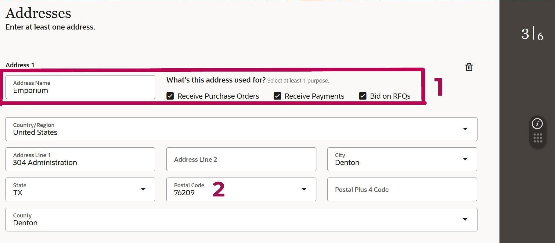

- In the Address Name field, enter the street address (see example below). Check the appropriate box(es) beside the Address Name - we suggest checking all three boxes.
  - Address Name Example: 123 Main St.
- Next, enter the postal code and then the address lines.
  - Providing the postal code first will auto-populate the city, state, and county.
  - Enter the plus 4 postal code if available.

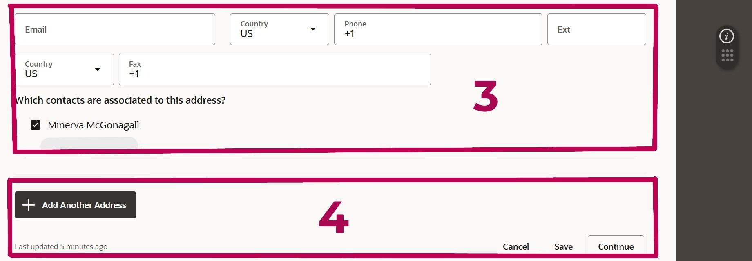

- Provide an email and phone number, then select which contact(s) to link to this address.
- Add another address if desired and click “Continue” when finished.

Business Classifications [4 / 6]

This section does not apply to students.
Click “None of the classifications” and click “Continue”.

Bank Accounts [5 / 6]

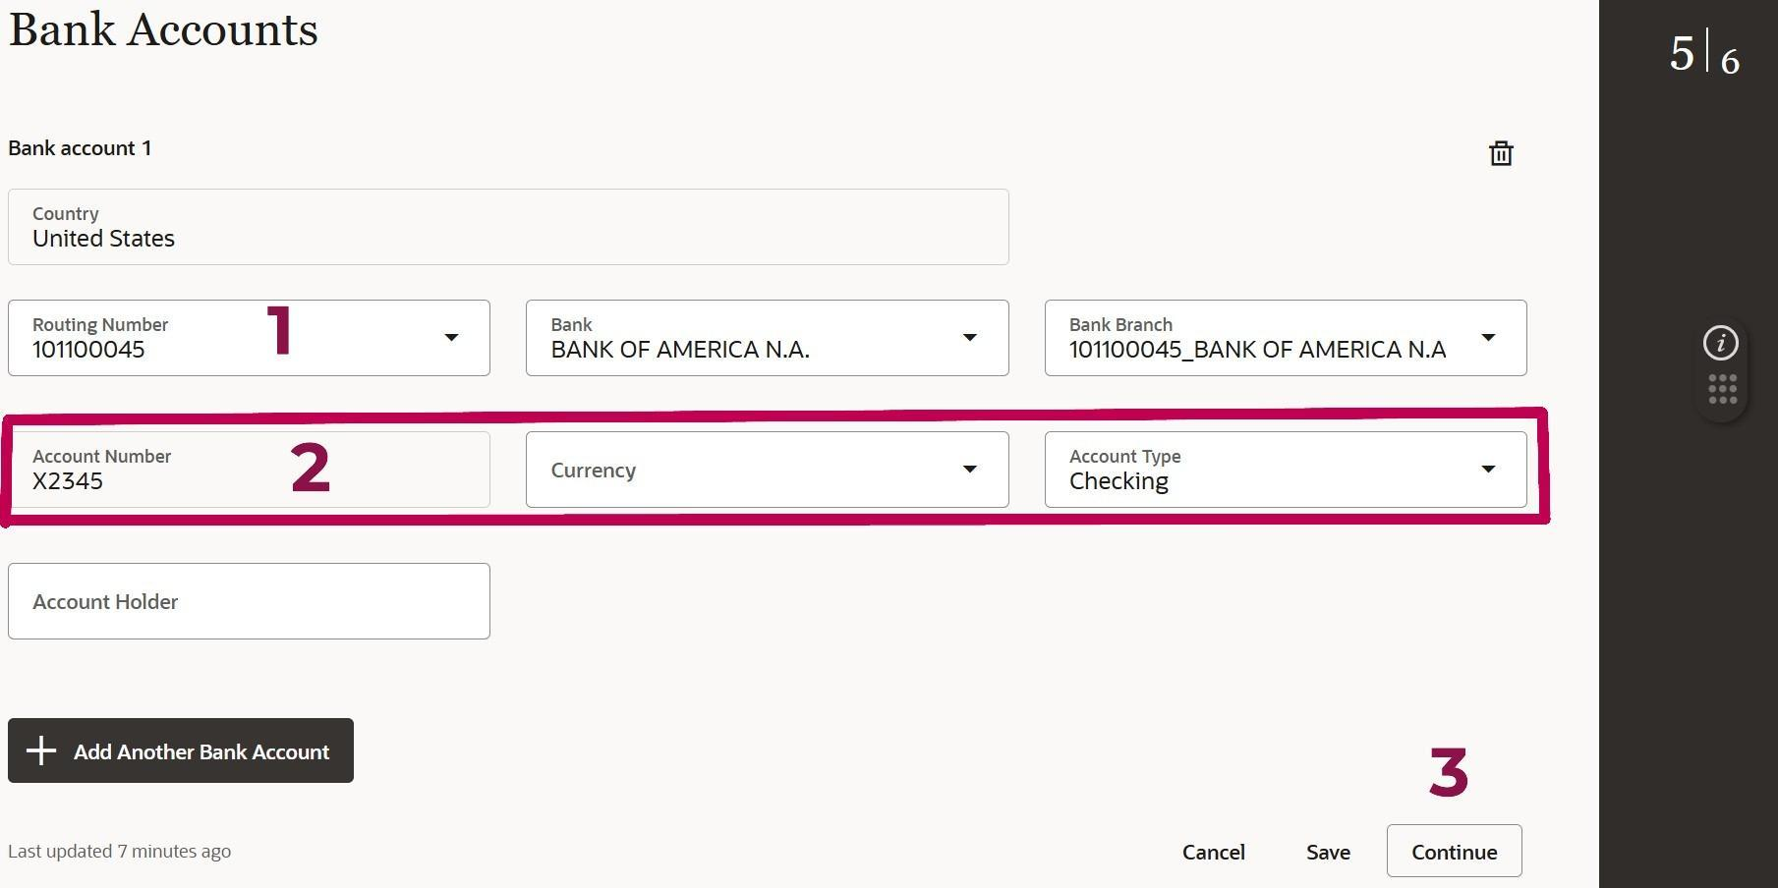

- Add your routing number in the Routing Number field. The Bank and Bank Branch will auto-populate.
  - If your routing number is not listed, contact TWUSupplier@twu.edu with your bank name and routing number.
- Enter the Account Number and select the Account Type.
- Once complete, click “Continue”.

Products and Services [6 / 6]

This section does not apply to students.

- Skip over the categories and click Submit.
- ***Click Submit to complete your registration***
  - Note: Clicking Submit is the only way to complete your registration. The Save button saves your progress, however your registration will be considered incomplete until you click “Submit.”

You’re all done!

Your request will be reviewed by Procurement and once approved, you will receive an email confirmation of your supplier profile.
Email TWUSupplier@twu.edu with any questions.

