How to respond to a Negotiation (Formal Bid) in Oracle Cloud Supplier Portal

- Navigate to your supplier portal: https://ewal.fa.us8.oraclecloud.com/

- Click the Home icon 
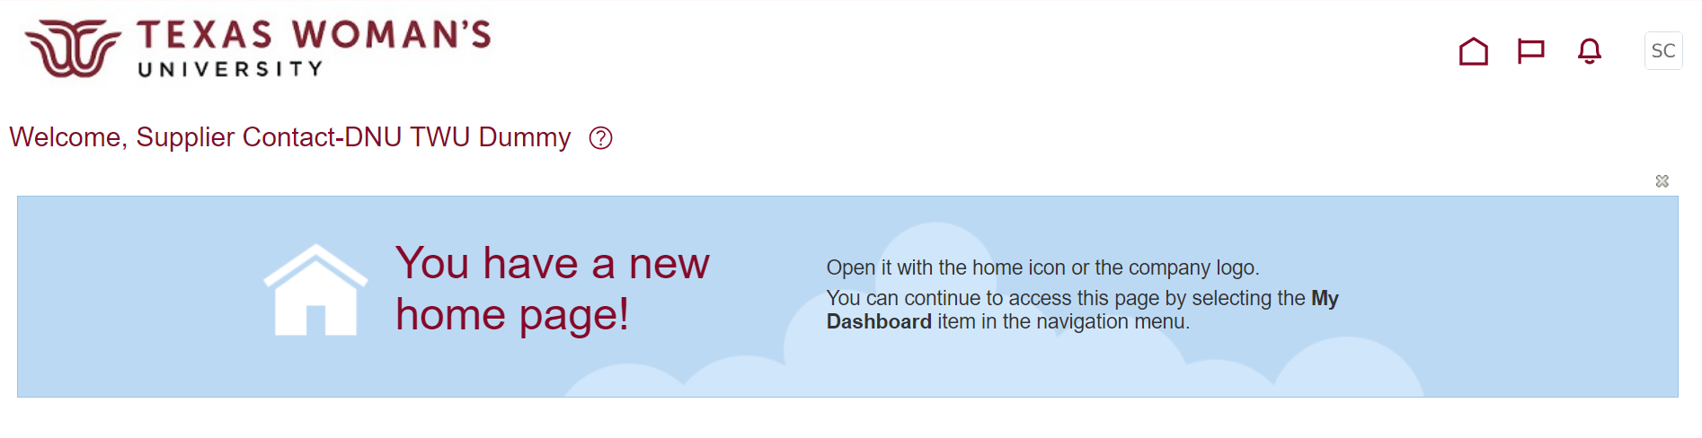

- Click the Supplier Portal tile

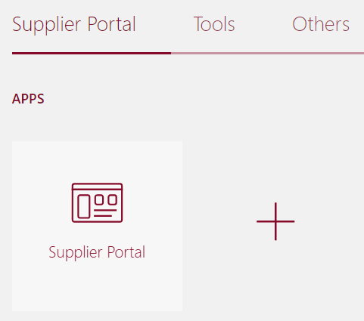

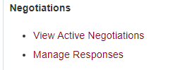
- Click View Active Negotiations
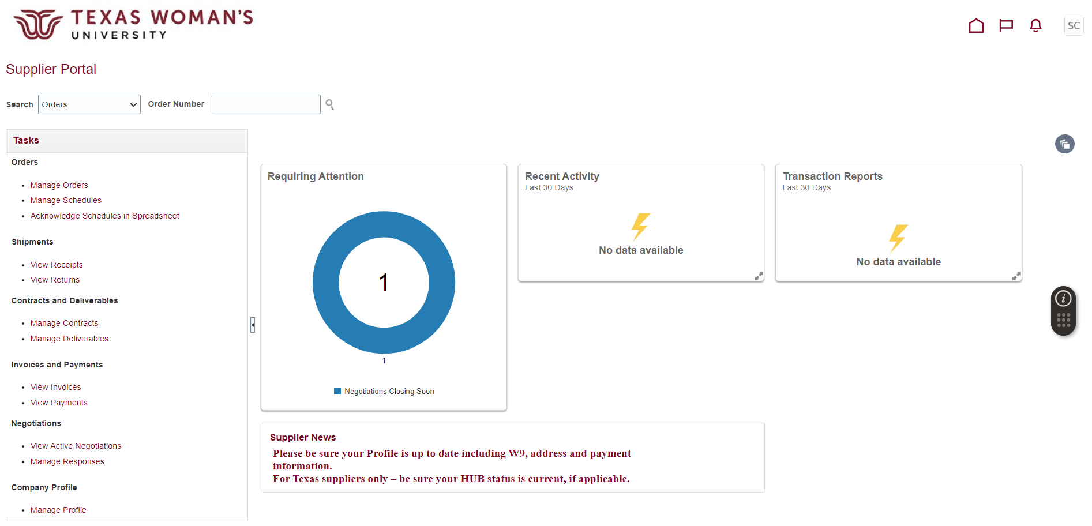

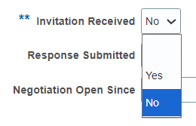
- Change Invitation Received to No, then click Search
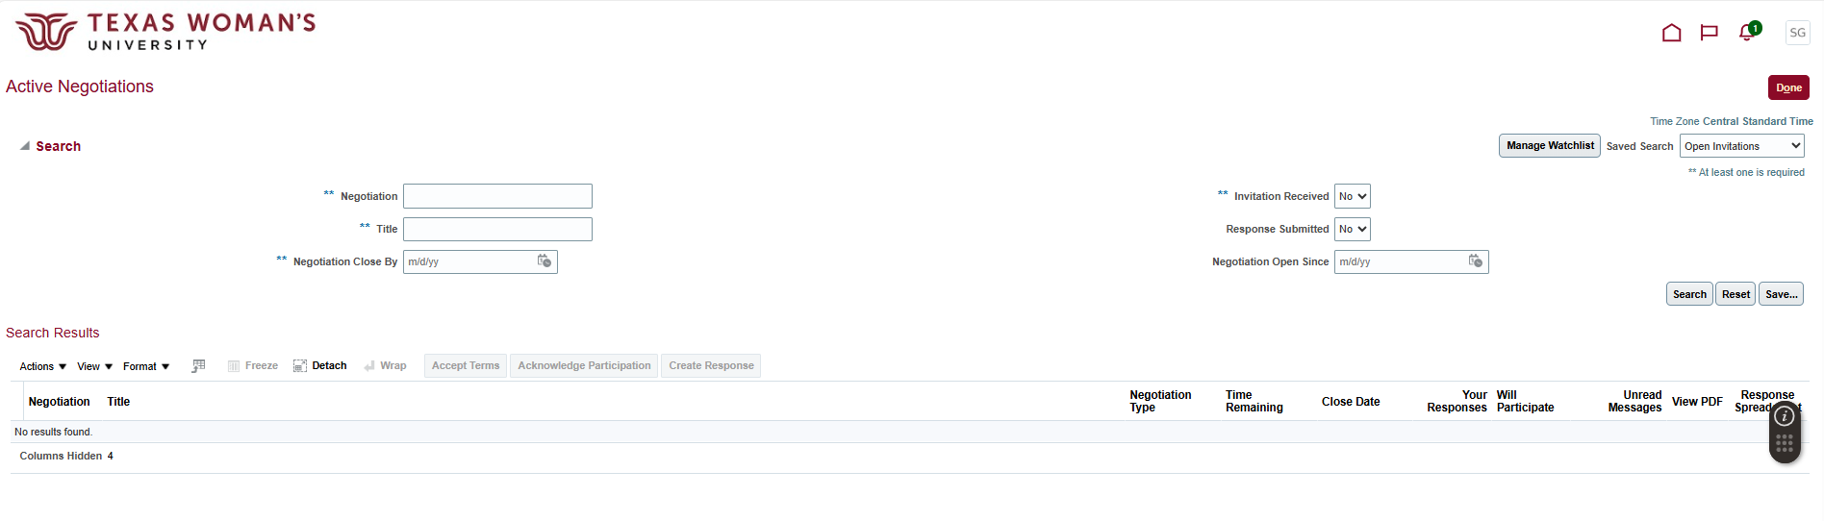

- Click the Negotiation number (in maroon font) 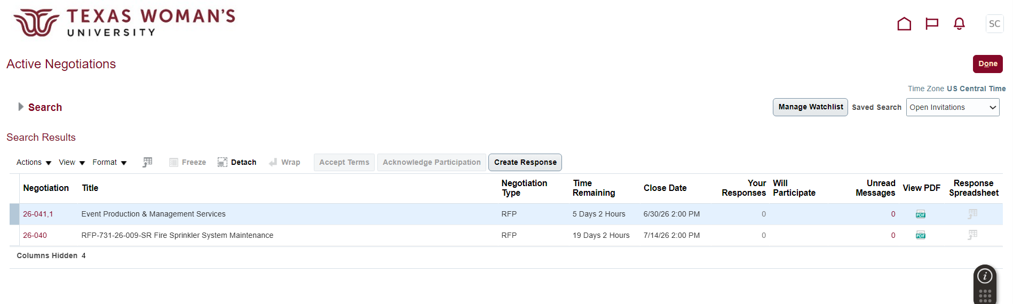

- Click Create Response.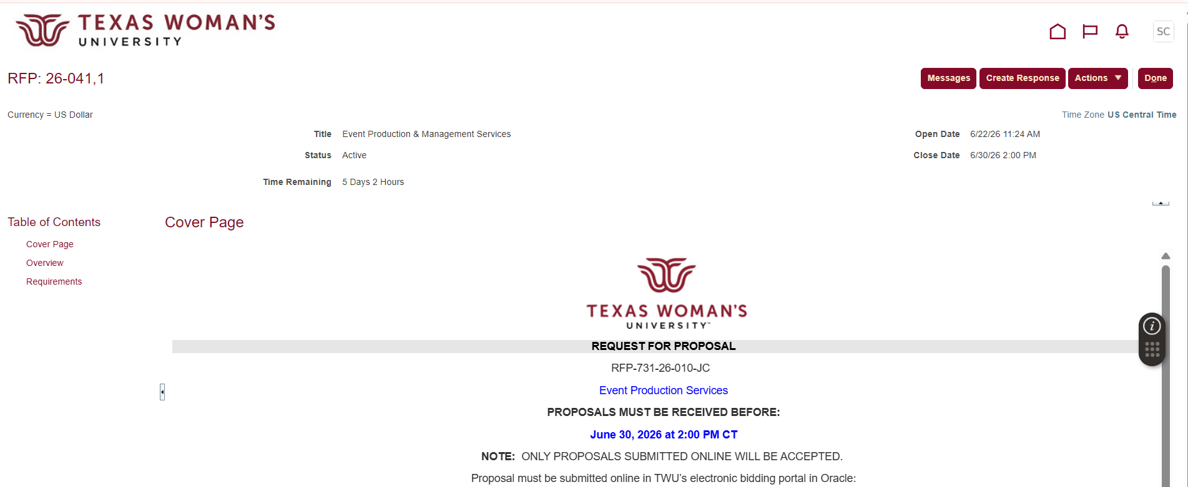

- Acknowledge any amendments made by clicking Yes in the Warning pop-up.
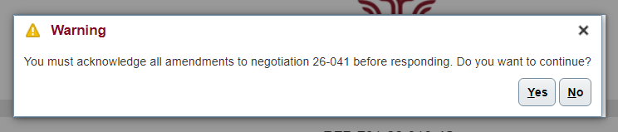

- Scroll down to the Overview section and view the attachments linked on the far right. 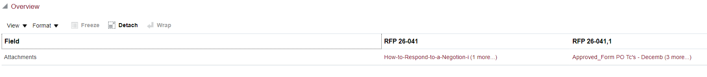

- Scroll back up to acknowledge that you’ve reviewed the amendment(s), then click Submit in upper right corner. 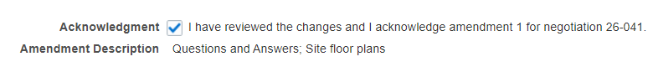

- Section 1: Overview - Click Next (nothing is needed on this page)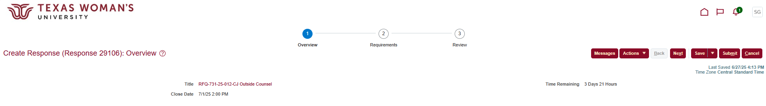

- Section 2: Requirements - Add “[Your company name] – Proposal” in the field above Response Attachments, then click + to add Response Attachments. 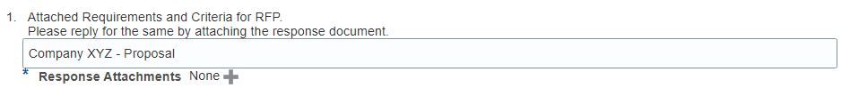

- Click the + icon, then the Choose File button to add an attachment. Click the + icon again for additional attachments. Once complete, click OK, then 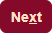.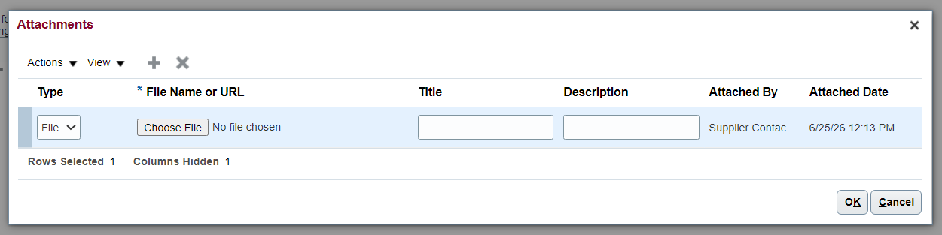

- Section 3: Review – Toggle over to Requirements and verify that your attachment(s) are linked.
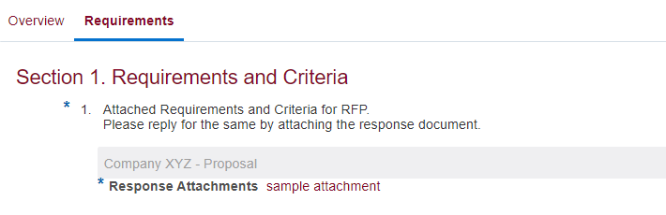

- Click Save , then click Submit 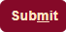.

- Your Confirmation will pop up and an email will be sent for your record. 