How to View Your Requisitions:

- Under the Procurement tab, click Purchase Requisitions:

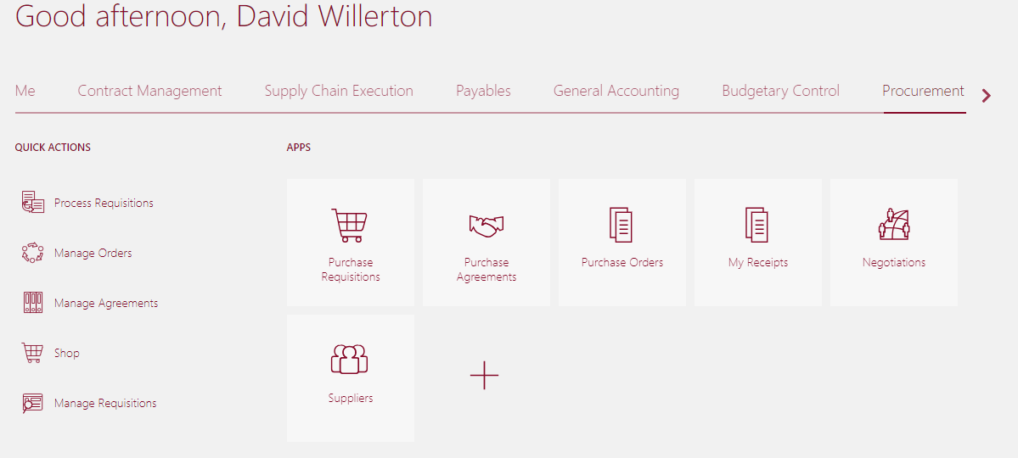

- Select Manage Requisitions:
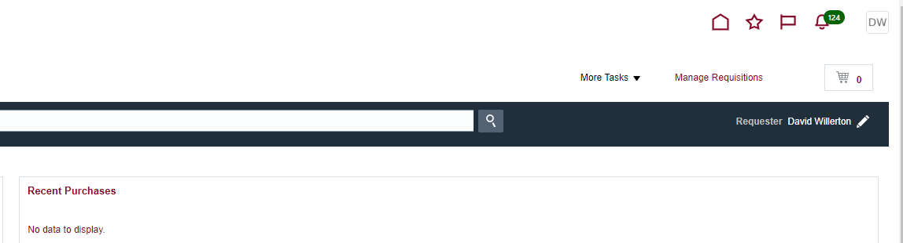

- Enter your name in the Entered By field.
- Click Search:

- You can also search using different criteria, but at least one required field (**) will need information.

