How to Update Requisition Preferences:

- Under the Procurement tab, click Purchase Requisitions:
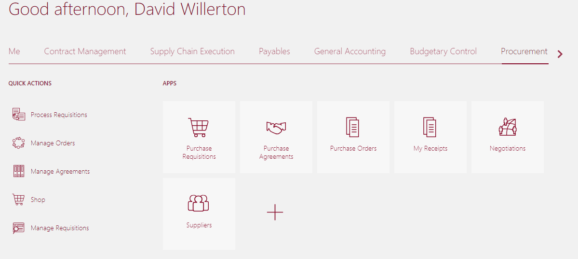

- Go to More Tasks drop down and select ‘Update Requisition Preferences’:
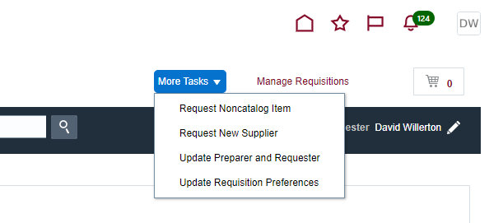

- Please update your default Deliver-To location and add or remove favorite charge accounts.
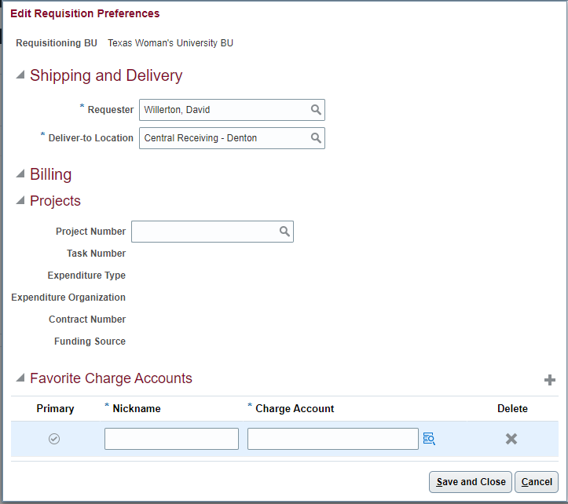
To add a new account to you favorites, click the ‘+’ icon on the right.
To delete an account, click the “X”.

- Enter your Charge Account number or use the search option to find the correct segments. Give the account a name to designate it. If you have multiple favorites, you can also designate one as your primary account:
- 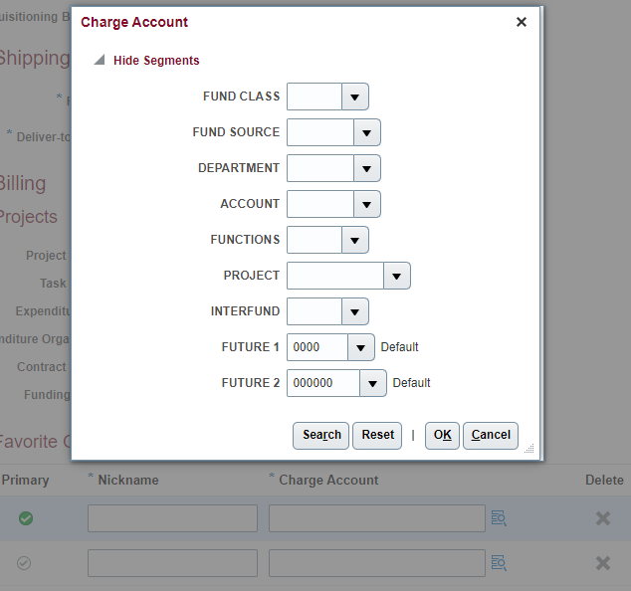

- When you are finished, Save and Close.

