**How to Remove a Receipt in Concur**

A common question we receive is, “I don’t see “Remove” on my meal receipt. How do I delete the receipt?”

This happens when you use ExpenseItto automatically attach receipts to your expenses in Concur. Here are the steps to remove the receipt.

1. Delete the meal from your expense report (it will go back to your Available Expenses list).
2. From your Available Expenses list, click on Payment Type of the expense. You’ll see the charge and the receipt in 2 pieces. Click Separate (then Separate again to confirm).

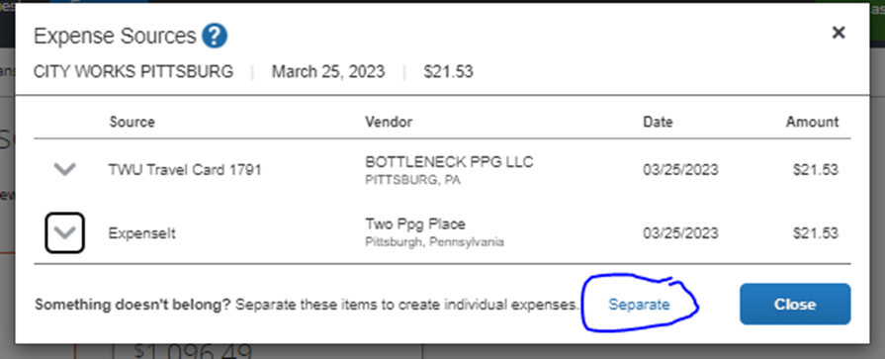

1. Now you’ll see two items in your list, the expense and the ExpenseIt receipt.

1. Click on the box next to TWU Travel Card expense, click the **Move To** button and choose the trip name to add only the expense to your Report. Enter the expense type and save the expense. The pending card transaction is a receipt and can be deleted if you prefer.

