How to Receive in Oracle Cloud
Under the Procurement tab, click on My Receipts.
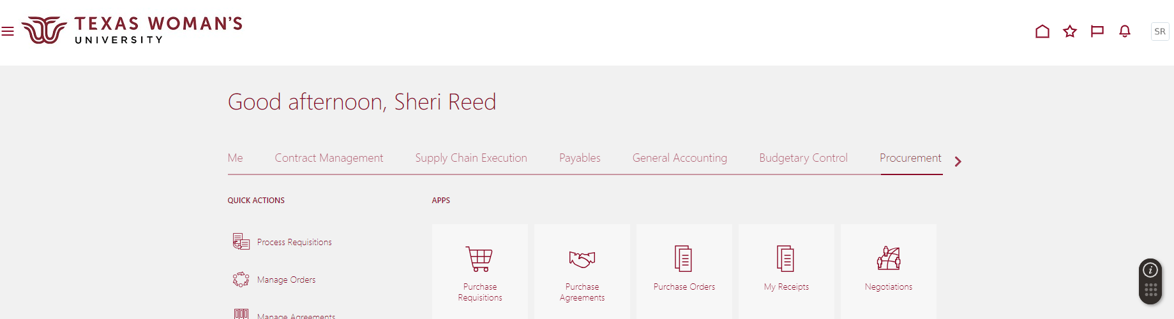
Your name should auto-populated in Requester field. Click drop down under Items Due - select Any Time. Requisitioning BU – select Texas Woman’s University BU. Enter PO number, click Search.
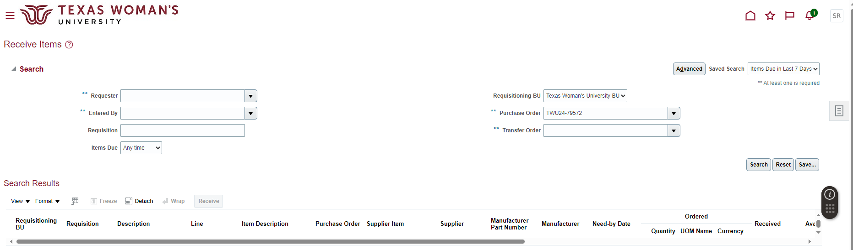
All lines on the PO will pull up. Highlight the line you would like to receive on, click Receive.
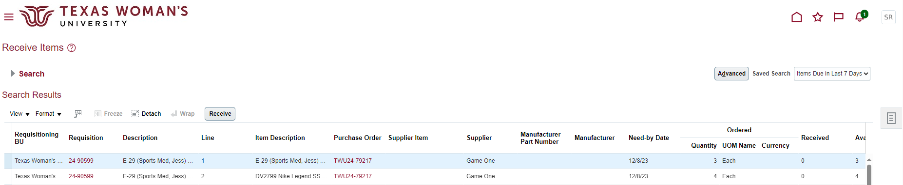

Enter the quantity to receive, click Submit.
