How to Receive in Oracle Cloud

- Navigate to Procurement > My Receipts.

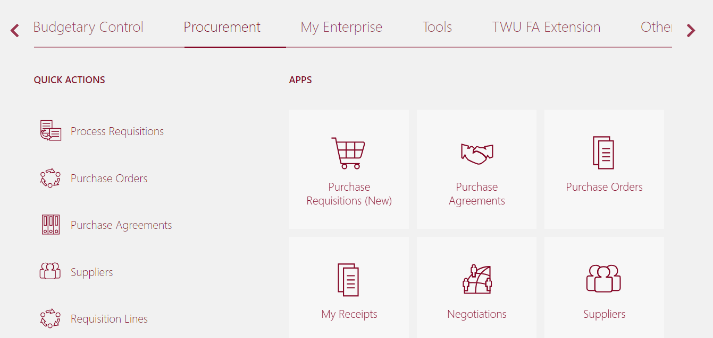

- Search for your Purchase Order (PO) using the following search parameters:
  - Requester = You
  - Items Due = Any Time
  - Requisitioning BU = Texas Woman’s University BU
  - Purchase Order = Your PO#
Click Search.
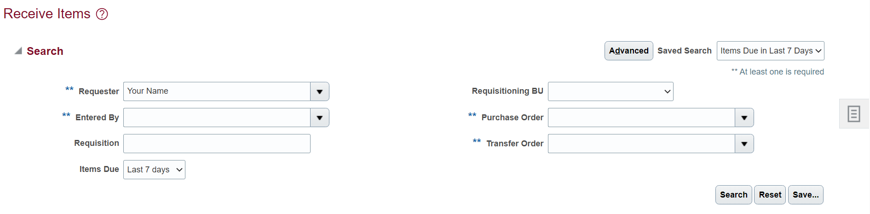

- All lines from the PO will pull up. Highlight the line you’d like to receive on and click Receive.


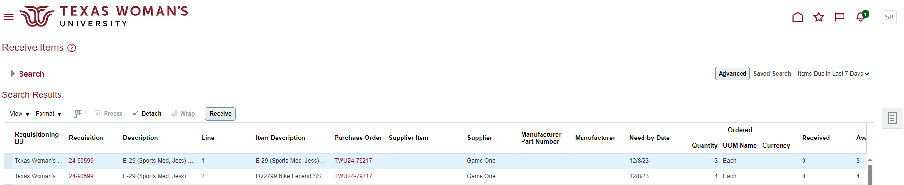

- Enter the quantity to receive then click Submit.

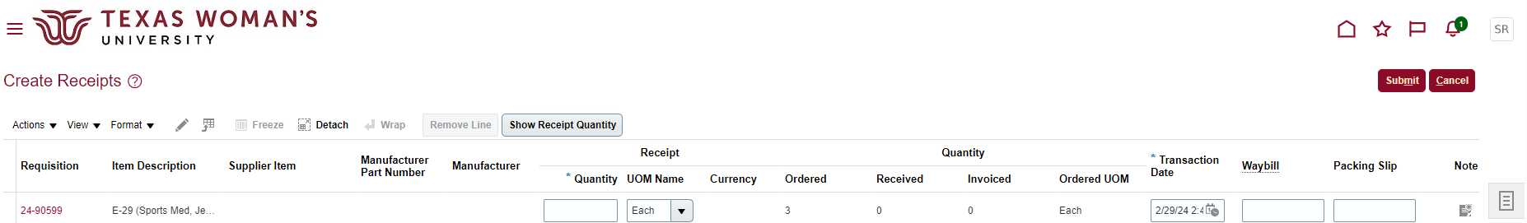

Alternatively, you can click Show Receipt Quantity to autofill the quantity field with the full remaining amount to be received.

