How to look up a PO in Cloud

- Under the Procurement tab, click on the Purchase Requisitions icon:
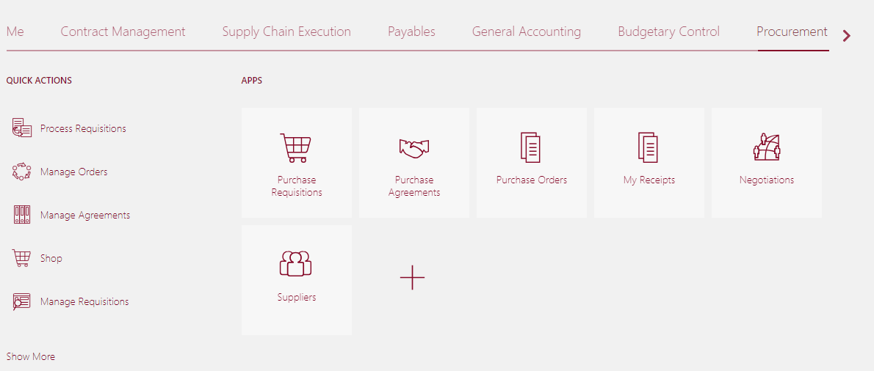

- Select Manage Requisitions near the top of the page:

- Enter information into at least one of the required fields (Entered by, Requisition number, Supplier, or Order).
- Click Search:

- When the requisition is found, if there is a PO associated with it, you will find a link to the right side of the search result where you can view details about it. Also, if you have the PO number already, you can enter it in the Order field along with at least one of the required fields.
