How to look up Requisition Line Life Cycle

- Under the Procurement tab, click on the Purchase Requisitions icon:
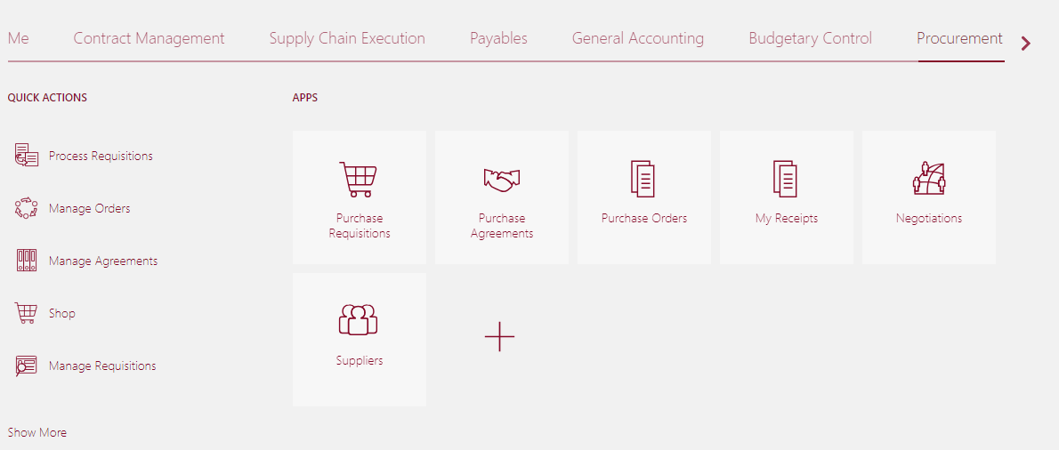

- Select Manage Requisitions near the top of the page:

- Enter information into at least one of the required fields (Entered by, Requisition number, Supplier, or Item). Click Search:

- Click the requisition link to view more details.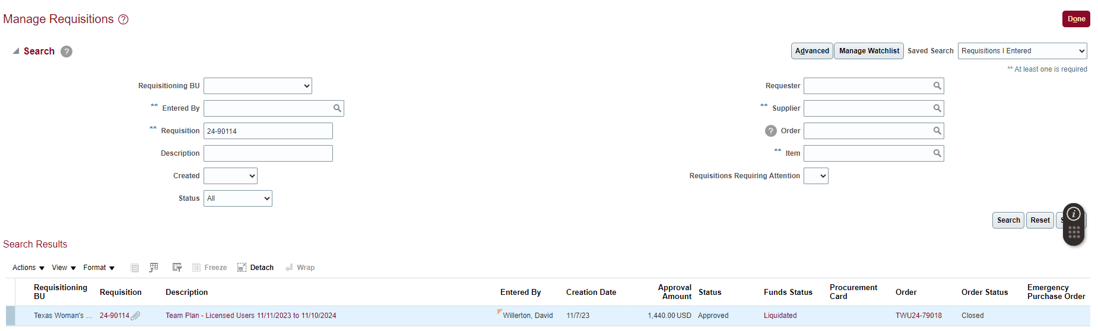

- Scroll all the way to the right and click Line Life Cycle.

- You will then be able to see Receipt and invoice information.
