Research Security Training Registration Instructions
- Go to the CITI Website and log in with your username and password.

- Click on “My Courses” at the top of the page.


- Scroll down and click on the blue “View Course” box to the right of “Texas Woman's University.”

- Scroll down to “Learner Tools for Texas Woman's University” and click on “Add a Course.”



- Scroll down to Question 9 and select “Research Security Training (Combined Course)” if you have never taken the CITI course. If you are taking it for the second time, please select “Research Security Advanced Refresher.”
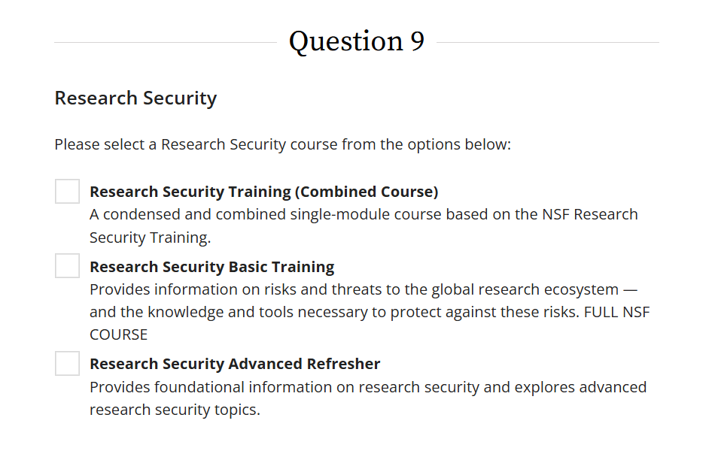
7. The course will now appear in the "Courses Ready to Begin" section of the "My Courses" tab.7.7

