

ANNUAL REPORT

FY 2023-2024

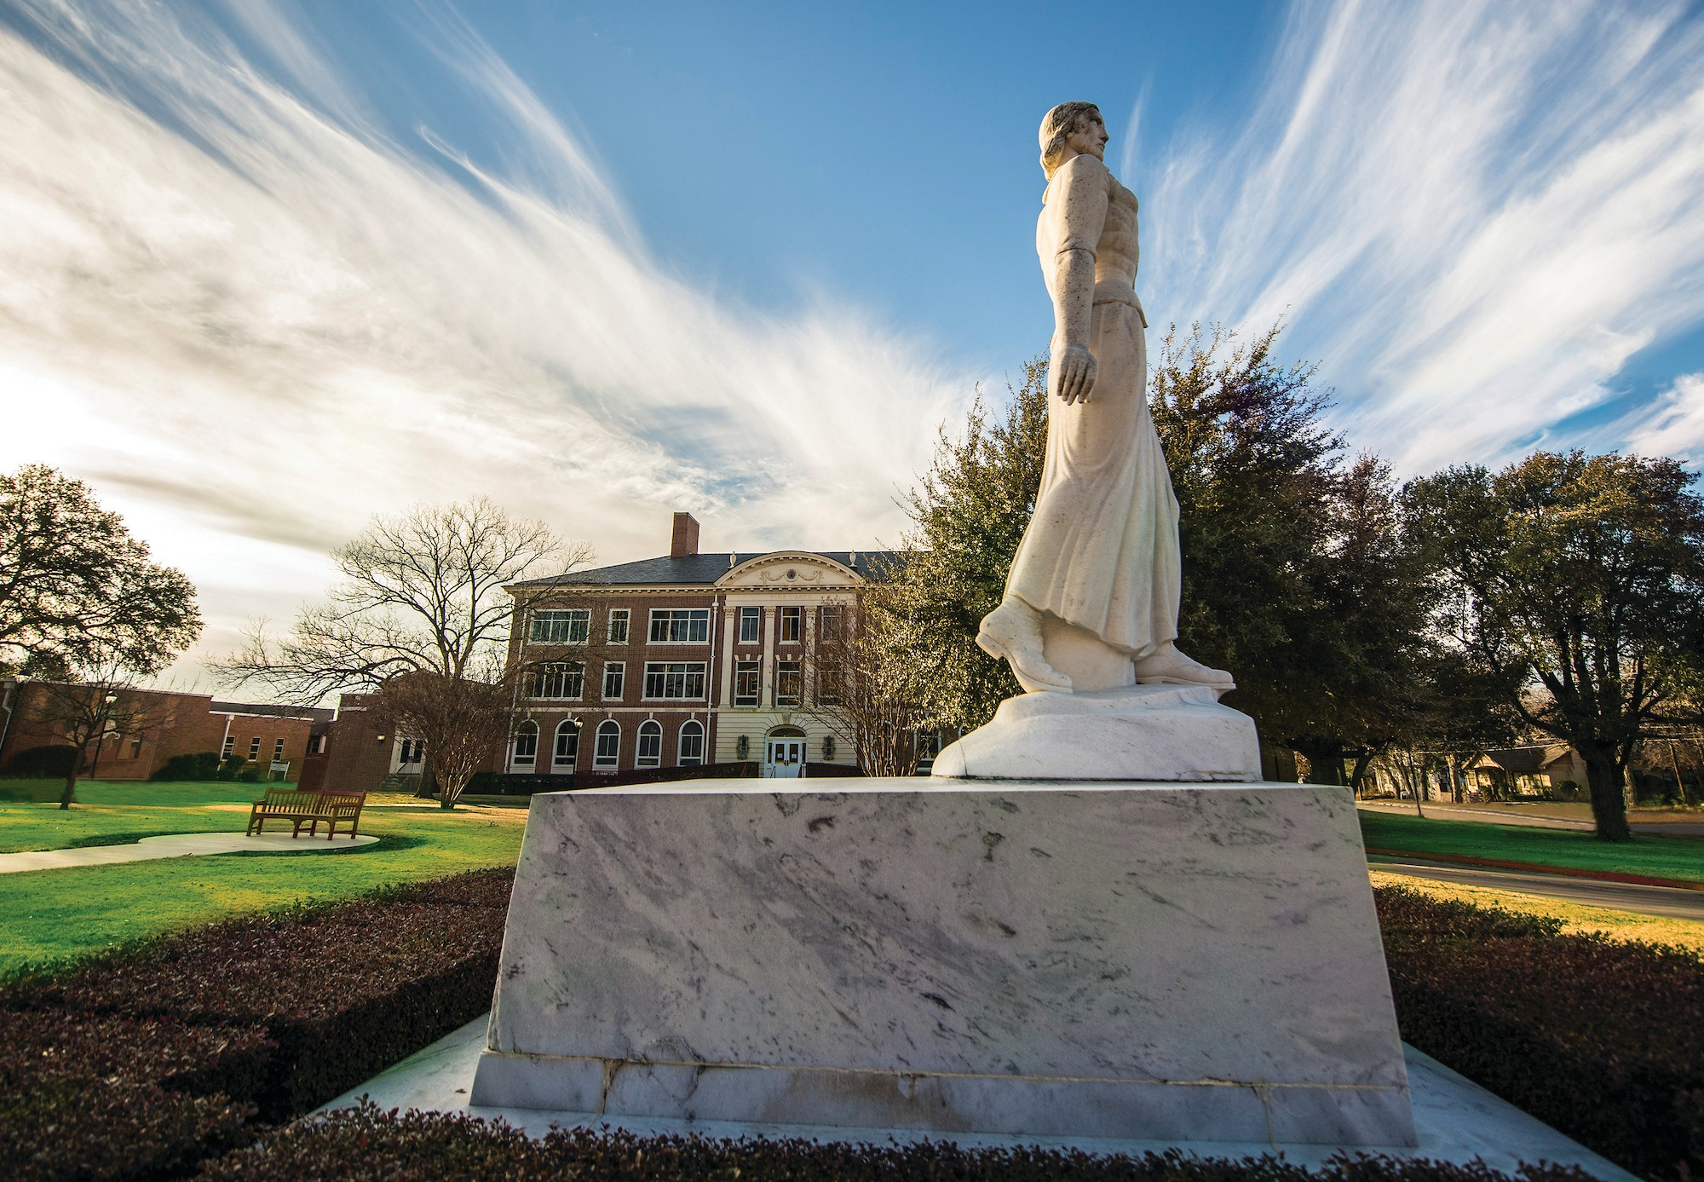

Table of Contents

Mission and Purpose 1

Highlights 1

Student Engagement By-the-Numbers 2

Student Research Grants Awarded 3

Student Research Presentation Grants Awarded 6

Student Research Publication Grants Awarded………………………………………………………………………………. 8

Compiled September 17, 2024
Contact: Dr. Diana Elrod delrod@twu.edu



Mission and Purpose
The mission of the Center for Student Research is to enhance the educational experience of students by providing opportunities for meaningful engagement in faculty-mentored research and creative activity opportunities. The purpose of the Center for Student Research is to promote an enhanced educational experience for students by providing opportunities for meaningful interaction between faculty and students through support, education, and programming in research and creative activities. The goals of CSR are to:
- provide opportunities for students to participate in all phases of research and creative activity, from design through dissemination;
- facilitate research partnerships between TWU students and faculty promoting faculty- mentored research opportunities for students;
- facilitate scholarly/creative partnerships between TWU students and faculty promoting faculty-mentored scholarly/creative opportunities for students;
- facilitate research collaboration between graduate and undergraduate students;
- enhance the students’ knowledge of all phases of research;
- promote a national presence for TWU students (i.e. National Council for Undergraduate Research - NCUR, Society for the Advancement of Chicanos and Natives Americans in Science - SACNAS); and
- ensure mutual benefit to both students and faculty members.

AY 2023 - 2024 Highlights
- Grants - Over $27,400 was awarded to both undergraduate and graduate students to support research and the presentation of research. The maximum for each award was $500 and 75 students (13 undergraduate and 62 graduates) were recipients. See individual award information section.
- Center for Student Research Workshop Series - Monthly presentations were provided virtually and topics included the following: Grad School and your Research; How To: Letters of Recommendations; and Imposter Syndrome and Your Research.
- Student Creative Arts and Research Symposium – For this symposium, over 240 abstracts were accepted for presentation and can be found in the 2024 Student Creative Arts & Research Symposium Program. The Chancellor’s Student Research Scholars were selected and received their awards. Students who accepted to the Symposium have been invited to place their research in the TWU Library Archives.

Student Engagement Summary  EVENT | # STUDENTS ENGAGED
Student Creative Arts and Research Symposium
Accepted Abstracts | 248
Poster Presentations | 143
Platform Presentations | 36
Virtual Presentations | 69
Total Presentations & Number of Students Engaged | 248*
* *As many abstracts had multiple authors, the actual number engaged is higher than the total number of abstracts.
CSR Student Research and Research Presentation/Publication Grant Awards
UG | 13
GS | 62
Total Engaged | 75
Workshops/Presentations/Individual Meetings
Total Engaged (UG & GS) | 150+
Total Engagements with UG & GS | 473+

2023-2024 Student Research Grants
Student(s)  Mentor  Department | Title of Research
Erica Agudo  Dr. Wyona Fresteinson  College of Nursing | The Experiences of Women Diagnosed with Gastroparesis While Viewing Themselves in a Mirror, Within Society and Intimacy
Eleonore Akuailou  Dr. Helen Everts  Nutrition & Food Sciences | Role of Dehydration/Reductase SDR Family Member 9 (DHRS9) in Epidermal Restoration After Acute Exposure to Ultraviolet Light B
Tneecia Leigh Applewhite  Dr. Samon Cottrell  College of Nursing | The Lived Experience of Patient’s with Idiopathic Anaphylaxis
Amit Basnet  Dr. Dayna Averitt  Biology | Immune Cell Dynamics in Rodent Trigeminal Sensory Neurons
Elizabeth Bergman  Dr. Rupal Patel  Physical Therapy | Are Clinical Findings Able to Predict Radiographic Hip Joint Morphology and Severity in Skeletally mature Adults with Hip Pain?
Jessica Jutte Bertram  Dr. Hui-Ting Goh  Physical Therapy | Physical Activity Participation During Chemotherapy for Women Affected by Breast Cancer
Charity Broomfield  Dr. Alannah Shelby Rivers  Psychology and Philosophy | Ignition Point Measure: M-Probe Replication of Seli et at. (2016) Study
Kanchan Budhathoki  Dr. Christopher Brower  Biology | To Generate and Inducible CRISPR/Cas9 System to Study Functionality of Liat1
Cayla Clark  Dr. Rhett Rigby  Science of Health Promotion & Kinesiology | Comparison of Heat Shock Protein Expression Between One Session of Whole Body Passive Heating and One Bout of Aerobic Exercise in Older Adults
Gage Connors  Dr. Juliet Spencer  Biology | Deciphering the Role of US27 in HCMV Infection Endocytic Trafficking, Recycling, and Gi Protein Sequestration
Cassandra Cornell  Dr. Judith McFarlane  College of Nursing | To Vaccinate or Not?: A Qualitative Study of Parents’ Lived Experiences on HPV Vaccination for Boys, Aged 9-12
Kevin Daae  Dr. Allanah Shelby Rivers  Psychology and Philosophy | Coping Mechanisms and Mental Health: Impact of Social Media Usage on Emerging Adults
Rory Etienne  Dr. Joshua Gold  Science of Health Promotion & Kinesiology | Sexual Orientation and Metabolic Syndrome (SOMS) Study
Erica Garcia  Dr. Juliet Spencer  Biology | The Effects of Human Cytomegalovirus on Breast Cancer Cells
Holly Griffin  Dr. Adesola Akinleye  Dance | Visions, Memories, Dreams
Teresa Hargrove  Dr. Della Molloy-Daugherty  Music and Theatre | Using Music to Manage Pain: A Qualitative Survey of Adults with Substance Use Disorder
Kassandra Hernandez  Dr. Azucena Verdin  Human Development, Family Studies, and Counseling | A Retrospective Study on The Experience of Coming Out on LGBTQ+ LatinX Adolescents
April Hill  Dr. Maria Peterson-Ahmad  Teacher Education | The Impact of Public School Transition Programs Upon Caregiver Burden
Chloe Horn  Dr. Juliet Spencer  Biology | Downstream Impacts of RhCMV Viral GPCRs
Bitali Islam  Dr. Dayna Averitt  Biology | Identification of Potential Mechanisms of Sex Differences in Orofacial Pain
Kelsi Lambright  Dr. Daniel Newmire  Science of Health Promotion & Kinesiology | The Effects of Menstrual Cycle Phase on Lactate, LDH, MCT1 & MCT4 Post Wingate
Ian LaRue  Dr. Juliet Spencer  Biology | Morphological Changes Induced by Infection with Human Cytomegalovirus (HCMV)
Anh Tuyet Le  Dr. Judith McFarlane  Nursing | Health Promotion Practices of Vietnamese Immigrant Women Living in the United States: A Qualitative Study
Kristen Meister-Davis  Dr. Fuqin Liu  Nursing | The Shaping of Nursing Professional Identity in Generation Z Nurses: A Narrative Inquiry
Kenneth Miller  Dr. Mary Thompson  Physical Therapy - Dallas | Reliability and Validation of the Professional Fulfillment Index with Physical Therapists
Kenneth Miller  Dr. Mary Thompson  Physical Therapy - Dallas | Exploration of Burnout and Moral Injury in Physical Therapists: A Nationwide Survey
Kindra Mitchell-Dorsey  Dr. Catherine Dutton  Human Development, Family Studies, and Counseling | Resilience in Black Ballerinas: The Impact of Family Support
Victoria Montalvo  Dr. Danhui Wang  Nutrition & Food Sciences | Investigating the Quality of Pea Microgreens Enriched with Probiotic Yeast
Elizabeth Olumodeji  Dr. Juliet Spencer  Biology | Investigating the Role of Human Cytomegalovirus (HCMV) in Breast Tumor Progression in Vivo
Tahmina Parveen  Dr. Danhui Wang  Nutrition & Food Sciences | Development of a Rapid Method for the Analysis of Expolysaccharides in Dairy Products
Katherine Pinkham  Dr. Julie Libersat  Visual Arts | Woven Traditions in a Digital Age: Revisiting Victorian Hairwork
Whiteney Charles Rodgers  Dr. Mikyoung Lee  College of Nursing | mHealth Applications Satisfaction Survey
Matthew Stankus  Dr. Mary Anderson  Biochemistry | Computer Simulated Docking of 2HGS and GCS
Ankita Thakkar  Dr. Fuqin Liu  College of Nursing | The Narratives of Asian Women Who Seek Treatment After Being Diagnosed with Depression
Vanessa Thyne  Dr. Mindy Patterson  Nutrition | Polycystic Ovary Syndrome and Resistant Starch: A Pilot Study
Phong Tran  Dr. Zhipeng Tao  Nutrition & Food Sciences | Dynamic Palmitoylation in Adipogenesis and Obesity
Christine VanBuren  Dr. Helen Everts  Nutrition & Food Sciences | The Localization of Retinol Binding Protein Receptor 2(RBPR2) in Epidermal Skin
Elisabeth Wise  Dr. Mary Thompson  Chemistry & Biochemistry | The Effect of Hand Mobility and Grip Strength Exercises on Upper Limb Volume, Quality of Life, and Hand Function in Breast Cancer Survivors
Peyton Yarbrough  Dr. Christian Hart  Psychology and Philosophy | Lies in the Dark: An Analysis of Dark Personality Traits and Dishonesty

2023-2024 Student Research Presentation Grants

Students  Mentor  Department |  | Title of Research Presentation or Publication
Juliet Adams  Dr. Alannah Shelby Rivers  Psychology |  | Examining the Relationship Between Treatment Perceptions and Coping Strategies in Type ll Diabetes
Emily Arellano  Dr. Alexis Hardesty  Mathematics |  | Realizing Groups of Order 2^n as Groups of Units
Lisa Aschenberg  Dr. Shanil Juma  Nutrition & Food Sciences |  | The Effect of Walnut Butter Product and Nutrition Education on Weight and Endothelial health in Overweight Adolescents
Juliana Azoubel  Dr. Adesola Akinleye  Dance Division |  | Brazilian Dance(s), Women Leadership, and Community
Amit Basnet  Dr. Dayna Averitt  Biology |  | Estrogen Modulates Inflammatory Mediator Release from Macrophages
Elise Bjork  Dr. Rupal Patel  Physical Therapy |  | Development, Content Validity, and Reliability of the Physical Therapy Social Determinants of Health Survey
Anne Brinkman  Dr. Lori Aaron-Brija  College of Nursing |  | Improving Access and Quality Care for Immune Checkpoint Inhibitor Related Thyroid Dysfunction
Jace Brown  Dr. Sharon Wang-Price  Physical Therapy |  | The Immediate Effects of Dry Needling on Infraspinatus Muscle Blood Flow in Asymptomatic Individuals
Cayla Clark  Dr. Rhett Rigby  School of Health Promotion & Kinesiology |  | The Effects of Equine-Assisted Therapy on Bradykinesia and Motor Function in Adults with Parkinson’s Disease: A Preliminary Analysis
Keith Crabtree  Dr. Shanil Juma  Nutrition & Food Sciences |  | Chondroprotective Action of Tart Cherry in the Monosodium Iodoacetate (MIA) Rat Model of Osteoarthritis
Shani Diouf  Dr. Charmian Wells  Dance |  | The African American Dancing Body: A Site for Religious Experience Through Dance
Trinity Douglas  Dr. Adam Jones  Human Development, Family Studies, and Counseling |  | Develop MFT Expertise: Learning Essential Skills
Ciara Easterling  Dr. Andrea Bennett  Management and Marketing |  | American Marketing Association International Collegiate Case Competition
Christine Gilfrich  Dr. Ana Louise Keating  Multicultural Women’s and Gender Studies/Language, Culture, and Gender Studies |  | Autohistoria-teoria as Queer Methodology
Aniah Harris  Dr. Allanah Shelby Rivers  Psychology |  | Faith's Healing Touch: Exploring the Impact of Religious Coping in Individuals with Type 2 Diabetes
Kate Hilton  Dr. Adam Jones  Human Development, Family Studies, and Counseling |  | MFT Expertise: Learning Essential Skills
Juliette Holder  Dr. Jackie Hoermann-Elliot  Language, Culture, and Gender Studies |  | "Honey, Life is Just a Classroom": The Feminists Pedagogical Potential of Taylor Swift-Themed College Courses
Savannah Honarbakht  Dr. Rebecca Lucero-Jones  Human Development, Family Studies, and Counseling |  | When State Laws Conflict with Ethical Guidelines
Bitali Islam  Dr. Dayna Averitt  Biology |  | Transcriptome Analysis of Trigeminal Ganglia Following Sub-Chronic Stress Exposure in a Rat Model of Orofacial Inflammatory Pain
Alaina Jordan  Dr. Richard Sheardy  Chemistry & Biochemistry |  | DNA-Gemini Surfactant Interactions: Sequence and Environmental Effects
Tae Goon Kim  Dr. Katy Mitchell  Physical Therapy |  | Predicting Academic Success in a Public PTA Program
Elizabeth Love  Dr. Rebecca Lucero-Jones  Human Development, Family Studies, and Counseling |  | Guiding Communication in Couples Post-Infidelity
Avery Martin  Dr. Junalyn Navarra Madsen  Mathematics |  | The History and Development of Women as Minorities in STEM
Ilse Mayte Mascorro  Dr. Charmian Wells  Division of Dance |  | Embodying Excess: Invisibility and Normative Belonging in Dance & Visual Arts
Dreanna McAdams  Dr. Hui-Ting Goh  Physical Therapy |  | Relationship Between Self-Reported Fatigue and Brain Activation During Reading: and fNIRES Study
Temiloluwa (Peace) Olaoluwa  Dr. Dayna Averitt  Biology | Euphorbia Bicolor Phytochemicals Reduce Oxidative Stress, Inflammatory Mediators, and Pain Signaling in a Rat Model of Burn Pain
Mafia Mahabub Rumpa  Dr. Camelia Maier  Biology | Euphorbia Bicolor Diterpene Extract Inhibits Growth of ER-positive and Triple-negative Breast Cancer Cells Through Multiple Apoptotic Pathways
Christina Salazar  Dr. Elizabeth Kaye  Literacy and Learning | “We Gonna learn About Real Things”: A Systematic Review of Critical Literacy with Elementary Students
Kimberly Townsend  Dr. Derek Miketinas  Nutrition & Food Services | Secular Trends in Body Composition, BMI, and Body Weight Among US Adults 20-59y
Khushali Trivedi  Dr. Jodi Thomas  Physical Therapy | Comparing Pelvic Floor and Core Exercises for Postpartum Lumbopelvic Pain: A Narrative Review
Brooke Trunnelle  Dr. Hui-Ting Goh  Physical Therapy | Relationship Between Self-Reported Fatigue and Brain Activation during Reaching: An fNIRS Study
Emma Willingham Ware  Dr. Wesley Tucker  Nutrition & Food Sciences | Impact of Menstrual Cycle on Submaximal Exercise VO2 and Critical Power in Active Eumenorrheic Females
Anna Whitaker  Dr. Alannah Shelby Rivers  Psychology and Philosophy | Affect Regulation in Adult Children of Narcissistic Parents: Examining the Impact of Perceived Parental Narcissism
Erika Zoellner  Dr. Wesley Tucker  Nutrition & Food Sciences | Effect of Menstrual Cycle on Objectively Measured Sleep in Active, Eumenorrheic Females
2023-2024 Student Research Publication Grants
Stephanie Lopez-Neyman  Dr. Derek Miketinas  Nutrition & Food Sciences | Association of Tree Nut Consumption with Cardiovascular Disease and Cardiometabolic Risk Factors and Health Outcomes in US Adults

