How to Choose the Correct Item Type on a Requisition
When creating a requisition, you MUST select Item Type “Goods billed by quantity” or “Services billed by quantity” (DO NOT select “Services billed by amount” as this defaults to “Fixed Price” on the line and does not allow a quantity to be entered.)
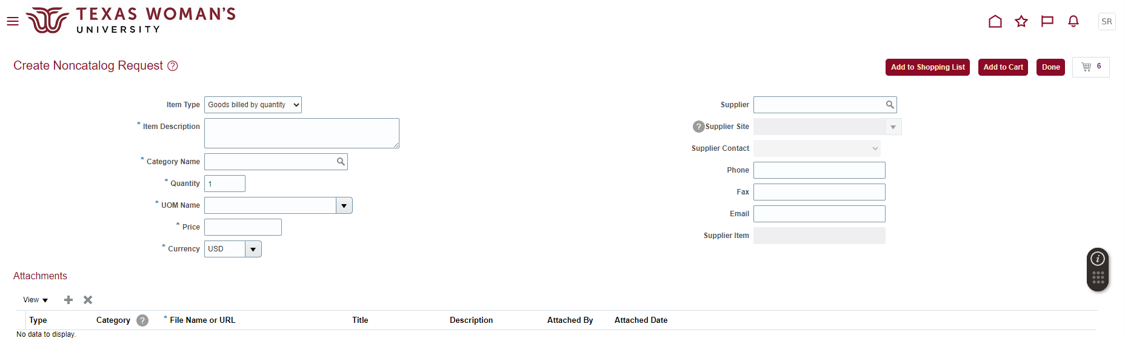
** If your requisition was returned, you will need to cancel the requisition and create a new one.

