How to Correct a Receipt in Cloud

Under the Procurement tab, click on My Receipts.
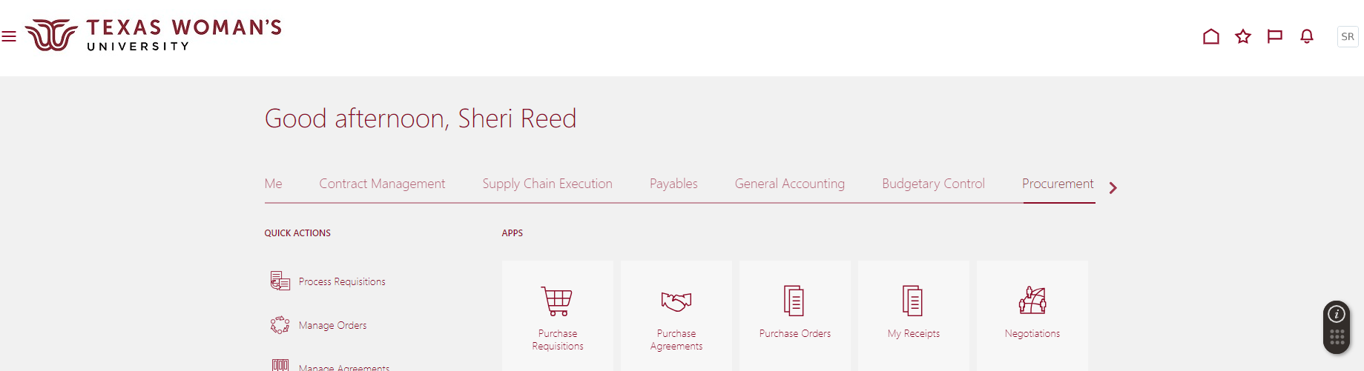

Click on Tasks (looks like a Notepad).
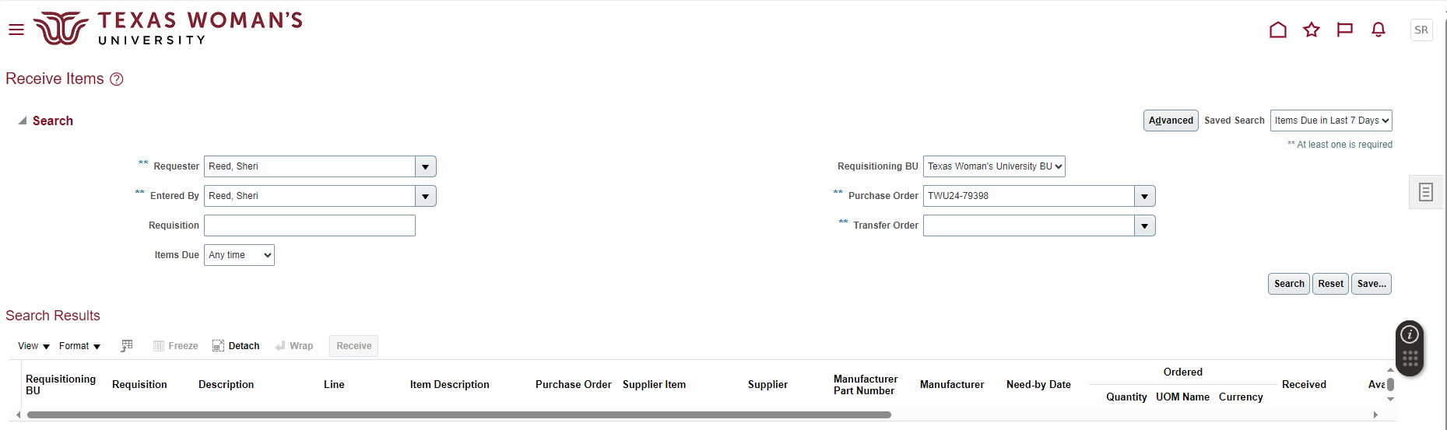

Click on Manage Receipts.

Change Items Received to “Any Time”.
Enter either the “Receipt” for a specific receipt number or “Purchase Order” for all receipts on that PO. Then click Search.
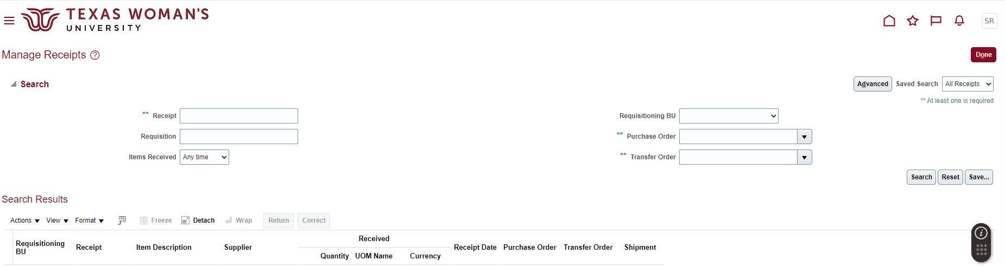

Select the line you would like to correct – click Correct.
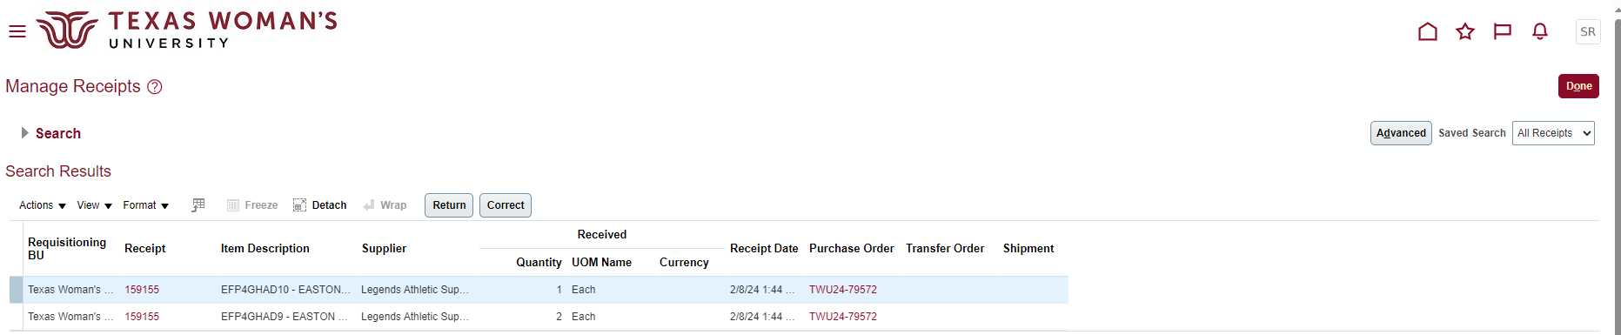

Enter the correct receipt amount – click Submit.
