Council for Educator Preparation
Meeting Agenda
October 5, 2018
11:30-1:00
Stoddard Hall 202A
Present:
- Call to order and attendance:
- Approval of Minutes
- Approval of Agenda
- Officer Reports
  - Field Experiences and Clinical Practices Committee--Sarah
  - Education Student Affairs Committee--Diane
    - Testing Policy for Professional Certs is live
    - Blocking ELDR course access unless student is enrolled in principal certification program; can override after double-checking. Will be doing the same for EDSP 5833 and 5843.
  - Academic Programs Committee--Becky
  - Dean’s Report
  - Chair/Vice Chair Report
  - Directors’ Reports
- Business
  - Old Business
    - CEP By-laws
      - CEP Executive Committee met on October 1st at 9:00am to work on Bylaws and all CEP members will be emailed the Bylaws to review and recommend changes. A vote to approve the By-laws will occur in November.
  - New Business
    - TEA - SBEC Meeting today
      - Set Principal Satisfaction Survey performance standard to 70% with no future increases.
      - Set non-PPR pass rates to 75% with no future increases.
      - Jan 1, 2020; undergrads may PACT.
      - Sept 1, 2020; updated exams for PE, ESL, 4-8 ELAR. Updated in that the exams will have additions content pedagogy items.
      - Sept 1, 2021; replace PPR with EdTPA. Updated exams: Bilingual, BTLPT, and 7-12 ELAR
      - Nov 1, 2021; updated exams for SPED, TASC, and DHH
  - Post-TEA Audit Reflection
    - Benchmarks alignment with transcript
      - Formal Admission - Professional Certification
      - Test Readiness
    - Field Experiences
      - Unqualified field supervisors
      - Untrained site and field supervisors
      - Missing field experience documents
    - Tk20 Adoption Timeline---SP 2019 pilot
      - EPP Admission Status
        - As soon as Colleague data are uploaded to Tk20 and UG/MAT students have Tk20 accounts, EPP applicants may log into Tk20 and check the status of their EPP application. It will look similar to this:

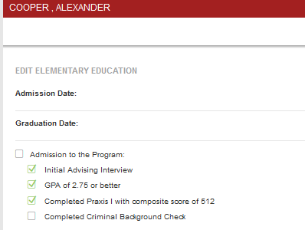
      - Time Logs
        - EDUC 4000s
        - LS 5843 - School Librarian
        - EDSP 5863 - Ed. Diag Practicum
      - Fall 19 Student Teaching Application
        - EDUC 4000s will already have Tk20 accounts so additional may be needed for MAT/PB who are ready to student teach
    - In anticipation of TAC 228.30(c)(8) “requiring the curriculum for all certification classes to include instruction in digital learning” becoming rule, below are the links to the pre- and post-assessments of the digital literacy exam that was vetted by the DTE faculty. Here is the game plan, I’ll update the EPP applications to include the pre-assessments links once TAC 228.30 is statute and we inform all program coordinators of the change. We will not offer acceptance to the EPP until the applicant meets all requirements for admission including the Digital Literacy pre-assessment. I’ve requested two new doc-types for OnBase so we can easily file the students results in their student file. Finally, the post-assessment will have to take place during student teaching, internship, or practicum. Linda will not recommend a student for certification until the post-assessment is complete.
Route | Pre-Assessment | Post-Assessment | Email Address Sent
Initial Certification | https://goo.gl/forms/j1xbhDkzTdfiQGQ02 | https://goo.gl/forms/IiL385LWCyzBavH12 | copeadvising@twu.edu
Professional Certification | https://goo.gl/forms/IsU5uVh0PmHimffA3 | https://goo.gl/forms/AAI3LK5KFn7FROQv1 | lkobler@twu.edu

We can add to this CEP agendas to let everyone know about this new statue, which was created by SB 1839 from the last legislative session (meaning no getting out of this).

- Adjournment

